**MASENO UNIVERSITY**

**SCHOOL OF PLANNING AND ARCHITETURE**

**DEPARTMENT OF URBAN MANAGEMENT**

**FOREST COVER CHANGE DETECTION USING GEOGRAPHIC INFORMATION SYSTEMS AND REMOTE SENSING TECHNOLOGIES ON MARAGOLI HILLS FROM 1985 - 2020**

SIMIYU NYONYENGESA OLIVER

PA/00085/2017

**PGS 426: PROJECT WRITING AND PRESENTATION**

**A RESEARCH DISSERTATION SUBMITTED IN PARTIAL FULFILMENT OF THE REQUIREMENT FOR THE AWARD OF DEGREE OF BACHELOR OF SCIENCE IN GEOSPATIAL INFORMATION SCIENCE OF MASENO UNIVERSITY**

## DECLARATION

This Research Project is my own independent work and has not been submitted to any other university for examination purpose(s).

Signature Date / / /

**Name: SIMIYU NYONGESA OLIVER**

**Registration Number: PA/00085/2017**

This Report has been submitted for examination with my permission

**Supervisor**

Prof. George M. Onyango

School of Planning and Architecture

Maseno University

## ACKNOWLEDEMENT

I acknowledge the Almighty Lord God for the precious gift of life He has granted unto me to enable me partake this endeavour, I recognize the rights and authorities of the beloved Maseno University and my Supervisor Prof. George Mark Onyango for providing the necessary materials, guidance, assistance, skills and environment to enable the smooth pursuit of this exploration, applaud my guardian **Jean Lily Munialo** for her support here and everywhere all together with the extended family at large, my friends for their brilliant ideas and insightful challenges to aid the completion of this examen.

## Table of Contents

DECLARATION ii

ACKNOWLEDEMENT iii

Table of Contents iv

ABSTRACT vii

LIST OF FIGURES viii

LIST OF TABLES ix

LIST OF ABBREVIATIONS x

CHAPTER ONE 1

1.1 Background of the study 1

1.2 Climatic conditions 1

1.2.1 Air temperature 1

1.2.2 Local precipitation 1

1.2.3 General precipitation 2

1.2.4 Relative humidity 2

1.2.5 Transpiration Loss 2

1.3 Biotic Conditions 2

1.3.1 Animal life 2

1.3.2 Source of Food for Animals 2

1.3.3 Source of Shelter and Protection 2

1.3.4 Animal Distribution 3

1.3.5 Water Retention 3

1.4.2 Wind Erosion 3

1.4.3 Water Erosion 3

1.4.4 Floods 3

1.2 Problem Statement 6

1.3 Objectives 6

1.3.1 Main objective 6

1.3.2 Specific Objectives 6

1.4 Research questions 7

1.5 Significance of the Study 7

1.6 Scope and Limits of the study 7

1.7 Definition of Key Terms 8

CHAPTER TWO 9

LITERATURE REVIEW 9

2.0 Introduction 9

2.1 Assessing Forest cover change 9

2.2 Remote Sensing and GIS in Forest Cover Change Detection 9

2.3 Description of change detection problems 10

2.3.1 Selection of suitable remotely sensed data 11

2.3.2 Image pre-processing 12

2.3.3 Factors contributing to forest cover reduction 14

2.3.3.1 Population growth 14

2.3.3.2 Agricultural use 15

2.3.3.3 Socio-economic effects on forest cover change 15

2.3.3.4 Timber harvesting and Fuel wood 16

2.3.4 Efficiency of GIS and remote sensing in Forest cover change detection 17

2.3.5 Knowledge Gaps 17

CHAPTER THREE 18

METHODOLOGY 18

3.1 Research Design 18

3.2 Study area 19

3.3 Study Population 20

3.4 Sampling 20

3.4.1 Sampling Frame 20

3.4.2 Sampling Procedure 21

3.5 Data Collection 21

3.5.0 Primary Data 22

3.5.1.1 Surveys 22

3.5.1.2 Interviews 22

3.5.1.3 Observation 22

3.5.2 Secondary data 22

3.5.2.1 Satellite Imagery 22

3.6 Data Analysis 22

3.6.1 Image preprocessing 22

3.6.2 Supervised Image classification 23

3.6.3 Forest cover change detection 23

CHAPTER FOUR 24

FINDINGS AND DISCUSION 24

4.0 Introduction 24

4.1 Objective 1: Identification of LULC classes and Forest Cover Change Extent among classes 26

4.1.1 Land Use Land Cover classes for Maragoli Hills Forest Cover 26

4.1.2 Accuracy Assessment 29

4.2.1 Overall accuracy 30

4.2.2 Kappa coefficient (KC) 30

4.1.3 Forest Cover Change Detection Analysis and Features Displacement 30

4.1.3.1 LULC Changes 1985-1995 31

4.1.3.2 LULC Changes 1995-2015 33

4.1.3.3 LULC Changes 2015-2020 36

4.1.4 Change Detection Analysis summary 40

4.2 Objective 2: FACTORS CONTRIBUTING TO MARAGOLI HILLS FOREST COVER CHANGE 40

4.2.1 Illegal logging 40

4.2.2Agricultural Expansion 42

4.2.3 Encroachment 43

4.2.4 Population growth 43

4.2.5 Fuel-wood harvesting 43

4.3 Objective 3: IMPACTS OF MARAGOLI HILLS FOREST COVER CHANGE TO THE ENVIRONMENT 44

4.3.1 Soil Erosion 44

4.3.2 Climate Change 46

4.3.3 Reduced amounts of Rainfall 47

4.3.4 Land Degradation/Desertification 48

4.3.5 Reduced biodiversity 49

CHAPTER FIVE 50

CONCLUSION AND RECOMMENDATION 50

5.1 Conclusion 50

5.2 Recommendation 52

REFERENCES 53

APPENDIX A: QUESTIONNAIRE 55

Section 1: Forest cover change 55

Section 2: Factors contributing to those changes 55

Section 3: Environmental effects of these changes 55

APPENDIX B: Key informant interview GUIDE 56

INTERVIEW WITH KEY STAKEHOLDERS OF MAAGOLI FOREST MANAGEMENT 56

Forest cover change questions 56

Factors contributing to the changes 56

Environmental effects of the changes 56

## ABSTRACT

Forests play vital roles in climate regulation and carbon sequestration. Maragoli Hills Forest is a natural forest in Mungoma Ward, Vihiga Sub-County, Vihiga County in Kenya and has been supporting the local community for construction, energy and household furniture. It has been influenced by land use land cover changes (LULCC) hence declining at alarming rates. Detecting LULCC by identifying extent of change from one class to another, understanding drivers of the changes and determining implications of the changes to the environment is important to support decision making processes for rehabilitative measures. A careful examination of forest cover variation dynamics from 1985- 2020 using Landsat images of 1985, 1995, 2015 and 2020 depicts results of LULCC change detection; human settlement increased by 24%, general vegetation by 1%, while forest areas decreased by 14% and bare lands by 11% of the total area. The changes resulted from; illegal logging 58%, agricultural expansion 15%, encroachment 13%, population growth 8% and fuel wood harvesting 6% leading to various impacts to the environment including soil erosion 46%, climate 21%, reduced rainfall 13%, land degradation 11% and reduced biodiversity 9%. Conclusions were made that illegal logging of trees was the major factor contributing to forest cover change with soil erosion as the senior-most implication to the environment emanating from the changes. Overall results hence suggest that forest areas should be clearly delineated and prevention of any forms of forest reserves misuse with heavy penalties to offenders in enabling forest cover preservation.

## LIST OF FIGURES

Figure 1: Methodological flow chart of forest cover change detection on Maragoli forest

Figure 2: A map showing the study area

Figure 3: Map showing Maragoli hills forest and close environs as study area

Figure 4: Diagram showing Data Collection Methods

Figure 5: A bar chart showing the occupational capacities of the respondents

Figure 6: A map showing distribution of LULC classes of Maragoli forest, 1985

Figure 7: A map showing LULC classes of Maragoli forest, 1995

Figure 8: A map showing LULC classes of Maragoli forest, 2015

Figure 9: A map showing LULC classes of Maragoli forest, 2020

Figure 10: A column chart showing distribution of LULC classes of Maragoli Hills forest

Figure 11: A map showing LULC changes from 1985-1995

Figure 12: Bar chart showing extent and area of forest cover changes from 1985-1995

Figure 13: Bar chart showing LULC changes from 1985-1995

Figure 14: A map showing LULC changes from 1995-2015

Figure 15: A bar chart and table showing the areas of each LULC class change

Figure 16: A bar chart visualizing the change of LULC classes from 1995-2015

Figure 17: A map showing change detection from 2015-2020

Figure 18: Bar chart LULC class and area changes from 2015-2020

Figure 19: Bar chart showing LULC changes from 2015-2020

Figure 20: A map showing LULC class changes from 1985-2020

Figure 21: Bar Chart showing summary and extent of LULC changes form 1985-2020

Image 1: A picture showing Depleted Maragoli forest due to tree cutting in Mungoma

Figure 22: Pie Chart showing Causes of Forest Cover Changes on Maragoli Hills Forest

Figure 23: A pie chart showing impacts of forest cover change on Maragoli hills forest

Image 2: A picture showing depleted murram sites in Vigetse village, Maragoli forest

Image 3: A picture showing local ballast extraction in Vihiga County

Image 4: A picture showing Tea farming as a major economic activity in Vihiga County.

## LIST OF TABLES

Table 1: Table showing steps of forest cover change detection

Table 2: A table showing cross- tabulation of gender and occupation of the respondents

Table 3: A table showing a Chi-Square Test of gender and occupation of the respondents

Table 4: A table summarising LULC classification with total area and percentage of each class from the total forest area.

Table 5: Summary of Accuracy Assessment from 1985-2020

Table 6: A table showing total percentage and area of forest cover changes from 1985-1995.

Table 7: A table showing a summary of LULC changes from 1985-1995

Table 8: A table showing the areas of each LULC class change

Table 9: A table showing LULC changes from 1995-2015

Table 10: A table showing LULC class and area changes from 2015-2020

Table 11: A table showing total area and percentage decrease/increase in LULC changes from 2015-2020.

Table 12: A table showing summary and extent of LULC changes form 1985-2020

Table 13: Table showing LULC change extent from 1985-2020

Table 14: Table showing summary of change extent in each LULC from 1985-2020

Table 15: Table showing factors contributing to forest cover change and responses on Maragoli hills forest from 1985-2020.

Table 16: Table showing impacts and responses of forest cover change on Maragoli forest

Table 17: Table showing extent of forest cover change on Maragoli forest

## LIST OF ABBREVIATIONS

GIS Geographic Information System

FAO Food and Agriculture Organization

NASA National Aeronautics and Space Administration

NEMA National Environmental Management Authority

GISS Goddard Institute of Space Studies

UN United Nations

LULC Land Use Land Cover

AOI Area of Interest

ND National Development

KFS Kenya Forestry Service

RS Remote Sensing

ArcGIS Aeronautical Reconnaissance Coverage Geographic Information System

# CHAPTER ONE

## 1.1 Background of the study

Forests are land occupied by trees in consideration to factors including tree height, tree density, land use, legal standing and ecological function. The Food and Agriculture Organization (United Nations FAO, 2015) defines a forest as land spanning more than 0.5 hectares with trees higher than 5 metres and a canopy of more than 10 percent or trees able to reach these thresholds. It does not include land which is under agricultural practice or urban use. They are predominant terrestrial ecosystem of the earth and they account for 75% of gross primary production of earth’s biosphere containing 80% of earth’s plant biomass.

Forests contain of complex natural systems in the world and the environment could be analysed into factors including, soil, moisture, wind and temperature among others. The psycho physiological influence of trees being purification of air, provision of clean water, rests and recreation, reduced noise, scenic enjoyment and spiritual replenishment areas, they are fully appreciated. Influence of forests on the environment forms a vast complex relation between environment and forest vegetation where the environment is the various components of the universe that affect life on earth. Man interferes the environment by destroying vegetation through over-exploitation and misuse.

With forests improving the environment through increase of relative humidity of air and increasing soil fertility, they influence;

## 1.2 Climatic conditions

The influences of forests on climatic conditions include;

## 1.2.1 Air temperature

The forest vegetation reduces annual mean temperature five feet above the ground depending on forest and locality especially elevation. Forests lower daily mean temperature in spring and summer while raising it in autumn and winter. They also lower daily maximum air temperature and raise the daily minimum.

## 1.2.2 Local precipitation

The influence of forests increases rapidly with increase in elevation particularly in mountainous regions whereas the influence is negligible in local precipitation at low elevation with effects of forests on precipitation varies with species, coniferous trees having greater influence than broadleaved species.

## 1.2.3 General precipitation

Influence of forests on general precipitation is greater than at local level as forest cover influences evaporation of water from land.

## 1.2.4 Relative humidity

The effect of forest vegetation, the relative humidity of the air appears to vary considerably in different localities, more particularly with differences in elevation. Forests, in checking the velocity of wind at and near the soil surface, in slightly raising relative humidity of the air in shading the soil, In lowering temperature and in covering the mineral soil with a mantle of leaves and other litter, retards rapid loss of moisture from mineral soil. Loss of moisture through evaporation from surface soil in the open on a windy day may be five times as great as loss of moisture from forest soil of similar character under protection of forest cover. Evaporation from snow surface in the open may be four times as rapid as from similar surface protected by a forest cover.

## 1.2.5 Transpiration Loss

A large percentage of water absorbed by vegetation is taken from the soil, enters the transpiration current and is returned to the air through the leaves. Forests lower the water level in the soil and that the layer of forest soil below the surface are usually dryer during the growing season.

# 1.3 Biotic Conditions

## 1.3.1 Animal life

Plants are the most important feature in the environment of terrestrial animals. All animals are dependent directly or indirectly upon plants for food. Forests also provides many animals with shelter from inclement weather, protection from enemies, situation for homes, and materials for nests.

## 1.3.2 Source of Food for Animals

Many forest animals feed very largely upon seeds, fruits, buds, leaves, twigs and other parts of forest plants, other feed in forests when food is plentiful there and scarce elsewhere.

## 1.3.3 Source of Shelter and Protection

Forests provide protection for most terrestrial ‘game birds’ which classed as game are more or less dependent upon forest for food and protection.

## 1.3.4 Animal Distribution

Forests play a vital role as they cause wild animals to move from place to place to seek for shelter, food and water.

## 1.3.5 Water Retention

Forest vegetation, by reducing surface runoff, increase the amount of water that percolates into a soil. The effect of forest in preventing freezing of forest soil of vast importance in increasing the amount of water that percolates into it, particularly during the spring months.

Forest cover in increasing the volume of soil in mountainous region over the solid rock foundation, increase seepage. The humus layers, characteristic of every well-managed forest, absorb from two to four times their weight of water. Forest soil, with its overlaying organic layers is in a real sense a vast sponge capable of absorbing much more water per unit area than soil in the open. Therefore water-holding capacity of humus rich soils is highly increased.

## 1.4.2 Wind Erosion

Soil is transported from one place to another either by wind or by water. Forests, by checking the velocity of wind and by reducing surface runoff have a great influence on the stability of soil. Sands subject to wind erosion should be covered with forest growth or their soil binding plants because permanent, stability can be attained only where sands liable to shift are so covered.

## 1.4.3 Water Erosion

One of the most important and far-reaching influences of the forest is the protecting of the soil from washing. Forest plays an important role in erosion control owing to the combined effect.

## 1.4.4 Floods

Forests, in reducing surface runoff and increasing seepage, extend the time over which precipitation reaches to streams. The most striking influence of forest vegetation on stream flow is shown whereby rainfall is provided by groundwater system.

According to the (United Nations FAO, 2015) 22.7% or about 674, 410,000 ha of Africa is forested. However, the forest cover is decreasing at an alarming rate where trees are being cut down at the rate of 4mn hectares per year which is twice the world’s record. With Forest Cover Change being referred to as the loss in natural areas, particularly forests as a result of urbanization and agricultural development. In Africa, more so East Africa, the rate of urbanization is so high ranging at 21% with 10% in Burundi, 14% in Uganda, 26% in Tanzania and 45% in Kenya. This therefore implies that natural settings are being displaced at higher speeds diminishing available natural resources in favour of urbanization. Humans also clear forests in pursuit for building materials like timber, charcoal, poles among other reasons ((Bernard Charlery de la Masselière, 2018). This can be attributed to the land use patterns that are visible following the interaction of human beings with the biophysical environment but as they struggle to meet their needs, they have modified and still continue modifying the land use with types consisting of residential, commercial, industrial and agricultural uses. Forests are being converted into grazing and agricultural areas for crop and livestock production, urban and industrial land, infrastructure such as roads and dams. Wetlands are being drained and converted for agricultural, recreational, residential and industrial uses. These human activities have caused diverse and adverse impacts on the society and environment.

Kenya is 6.1% or about 3,467,000 ha forested according to (United Nations FAO, 2015) with 18% of the forest being considered as primary forest. Kenya forests contain 476 million metric tons of carbon living in biomass. Biodiversity and protected areas Kenya had 1847 known species of amphibians, birds, mammals and reptiles from figures of World Conservation Centre. Kenya also has at least 6506 species of vascular plants. Change in forest cover between 1990 and 2010, Kenya lost an average of 0.32% per year and lost 6.5% of its forest cover between these years. Clearing of forests for various purposes cause numerous environmental problems from demolishing of wildlife habitat which releases stored carbon and hence contributing to global warming. It also causes increase in spread of life-threatening diseases such as malaria and dengue fever since the forest acts as incubators for insect-borne and other infectious diseases affecting humans.

Loss of forest cover can be articulated to expansion of agricultural land which ruin the balance existing between different land use types in Kenya and this intensive pressure on land impacts agricultural production, conservation, and tourism which later affects the biological system to support human needs to. Reduction of vegetation cover has reduced the ability of the land to absorb excess carbon dioxide from the atmosphere causing its high concentration and that of greenhouse gases (methane, nitrous oxide, carbon dioxide among other aerosol gases) which trap excess sunlight heat instead of allowing it to reflect back to the atmosphere causing depletion of the ozone layer which traps harmful ultraviolet rays from the sun thus bringing about rise in global temperatures, climate change, extreme weather conditions and acid rain. Ongoing temperature analysis by NASA Goddard Institute for Space Studies (GISS) increase of 0.80 Celsius has occurred since 1880 with two-third of warming having taken place since 1997, at rate of 0.150C to 0.20C per decade. This is a great threat of climate change and consequences that are associated with it. (IPCC, 2019).

Maragoli hills forest being in the Vihiga County of Kenya, has suffered massive destructions over the past years due to various reasons including expansion of agricultural land and tree logging. The changes bring dire effects on the environment and people’s lives and it is in this view that land use and management are entrenched into the Constitution under Article 260 that emphasises on importance of land on the environment especially the physical environment. Problems concerning land use in Kenya are failing agricultural production, land degradation, land use conflicts from urban and industrial expansion as well as prolonged unpredictable droughts thus limiting the use of land to sustain livelihoods (NEAP 1994). Mwagore (2002) observes that in western Kenya, Vihiga County, agricultural potential is under-utilized and land-use practices do not support profitable production.

Remote sensing and geospatial science try address matters concerning forest cover reduction by enabling the detection of changes occurring in forest areas and providing essential information to stakeholders so as to establish measures to mitigate the action. This is through the aide of satellites landsat-7 launched in 1999 and landsat-8 launched recently on 2015. They were developed to take digital images with global coverage on seasonal basis. The images recorded by these satellites have been of great use in projecting the trend of how forest and other land cover is changing over time. Images obtained from these satellites are carefully analysed and result used by various stakeholders such as environmentalist on making decision on preservation of nature. They are basically guided by three environmental ethical principles; to serve the public interest in case of many conflicting land use, maintain public confidence and to recognize the comprehensive and long - range nature of environmental planning decision.

## 1.2 Problem Statement

Kenya suffers loss of forest cover at alarming rates causing serious consequences to its population in the areas affected. National Environmental Management Authority (NEMA, 2012) states that Kenya had 5.9% of forest cover which was below the minimum required percentage of cover and had still suffered deconstruction. Deforestation which is the change in forest cover, for various factors including human settlement among others has resulted into serious environmental degradation problems at worrying levels with river drainage from catchment areas being highly affected thus diminishing the water quality and huge sediments loading resulting from heavy soil erosion.

Destruction of Maragoli Hills forest is said to have been driven by some “government officials” and human activities including logging and charcoal burning. Small scale farmers tend to collect fuel wood, construction materials, wild foods, and other forest products for subsistence (Nerfa et al. 2020). With agricultural expansion into forest land, timber logging, charcoal production being major drivers of deforestation in Africa according to (Declee et al. 2014; Muhati et al. 2018). Although there have been studies that have tried to show the changes in Land Use Land Cover (LULC), it is not clear to identify to what point the changes have taken place, respective causations and the repercussions following the very changes to the environment. This study thus tries to bring out clearly the changes that have taken place on the forest and to what the extent, the causes and impacts of these changes to the environment.

# 1.3 Objectives

## 1.3.1 Main objective

To determine forest cover change on Maragoli Hills forest using GIS and Remote sensing since 1985 to 2020.

## 1.3.2 Specific Objectives

1. To identify Land Use Land Cover classes and determine the extent of change from one class to another
2. To determine factors contributing to forest cover changes
3. To identify impacts of Maragoli forest cover changes to the environment

## 1.4 Research questions

The above problem statement and objectives therefore guided the research with the following questions:

1. What are the major LULC classes of Maragoli Hills forest and what changes have
2. What are the main causes of Maragoli Hills forest cover change?
3. What are the impacts of Maragoli Hills forest cover change to the environment?

## 1.5 Significance of the Study

Any changes on forest cover and vegetation brings about various implications to the environment such as climate change, desertification, soil erosion, increased greenhouse gases, depletion of water catchment areas and host challenges for wild animals. Following the destruction of the Maragoli Hills Forest, this study is viable to find out causes of the demolition of water catchment areas noted as a problem facing Vihiga district according to (NEMA, 2012).

Therefore, this study was necessary to show the extent of changes that have taken place on the forest cover from 1985 to 2020 so as to better plan on rehabilitating the degraded/changed areas of Maragoli Hills Forest.

The inquest was also viable considering the importance attached to environmental issues in the UN 2030 Agenda for Sustainable Development which Kenya is a signatory. Specifically, Goal 6 and 15 commits members of the international community to ensure availability and sustainable management of water and sanitation for all and to protect, restore and promote sustainable use of terrestrial ecosystems, sustainably manage forests, combat desertification, and halt and reverse land degradation and halt biodiversity loss.

Thus, the careful extended consideration was necessary for generating information and awareness about the degradation process on the Maragoli Hills and provide insight on new strategies that could be adopted to achieve community acceptance and participation in rehabilitation and protection of forests and conservation of the environment.

## 1.6 Scope and Limits of the study

The examen on the Maragoli Hills Forest found south of Chavavo, south of Makuyu in Vihiga County, Kenya with an elevation of 1640 metres. The main focus is to find changes that have transpired on the forest since 1985 to 2020 using GIS and Remote Sensing.

The probe tries to find out to what point changes in forest cover have taken place on the above Area of Interest (AOI). More so, the study will focus on finding the causes of forest cover changes and the impacts to the environment following the changes.

The study was limited to finding Forest Cover Change only on Maragoli Hills Forest using following the limited time and resources allocated Geographic Information Systems and Remote Sensing. This is due to the limited time awarded for data collection as well as resources.

# 1.7 Definition of Key Terms

**Forest cover**- All lands more than one hectare in area with tree canopy density of more than 10%.

**Change detection**- A process of measuring how attributes of a particular area have changed between two or more periods.

**GIS**- A computer system that analyses and displays geographically referenced information using data attached to a unique location.

**Remote Sensing**- Process of detecting and monitoring physical characteristics of an area by measuring it’s reflected and emitted radiation without physical contact with the surface.

**Land Use Land Cover**- Land cover indicates the physical land type such as forest or open water whereas land use documents how people are using the land.

# CHAPTER TWO

# LITERATURE REVIEW

## 2.0 Introduction

This chapter provides relevant literature review relating to forest cover change detection, causes of forest cover change and impacts of the changes to the environment.

## 2.1 Assessing Forest cover change

This is the replacement or change from a forest to non-forest state of a forested area. The world's forest ecosystem is in a state of permanent flux at a variety of spatial and temporal scales. Monitoring techniques based on multispectral satellite-acquired data therefore pose great potential as means to detect, identify, and map changes in forest cover. Maragoli Hills Forest suffers serious deforestation for human settlement which has caused environmental degradation up to alarming levels with river drainage from water catchment areas being highly impacted leading to declining water quality and heavy sediment loading due to heavy soil erosion. Destructive sand harvesting practices are also slowly emerging downstream the river banks, further complicating conservation efforts.

This chapter reviews various studies conducted to assess forest cover change in different parts of the world, contributing factors to the changes and impacts of the changes to the world population with regards to forest cover change.

## 2.2 Remote Sensing and GIS in Forest Cover Change Detection

Remote sensing is the process of detecting and monitoring physical characteristics of an area by measuring its reflected and emitted radiation at a distance (satellite/ aircraft). With the launch of Landsat-1 in 1972 marked the on-set of satellite remote sensing and with its ability for repetitive data acquisition, satellite-based sensors hold the potential to detect, identify, and map canopy changes that are important to the forest ecosystem managers. Aldrich predicted in 1975 that "Even low-resolution data from the Landsat MSS scanner, if combined and enhanced, will disclose 80 to 90% of the exchanges of land use between forest and non-forest categories. In addition, such data will show 25 to 90% of the less distinct disturbances in the forest, depending on the category." Remote sensing has also been used in numerous fields including geography, land surveying and earth sciences among other vast applications.

With recent developments of image processing of satellite imagery from 1960s and 1970s, several research groups have developed techniques leading to enhancements of imagery data which have later brought about capabilities of detecting changes on forest cover as a major application of remote sensing in forestry. In the world of today, remote sensing has become a source of detailed land management information in GIS that is compatible and in digital format worldwide.

Remote sensing data is most commonly for detection, quantification, and mapping of LULC patterns due to its repetitive data acquisition, suitable for processing, and accurate geo-referencing as emphasised by (Chen et al., 2005; Jensen, 1996).

The repetitive coverage nature of earth-orbiting satellites with short intervals and high image quality, remotely sensed data is effectively used for change detection which identifies differences in the state of an object or phenomenon by observing it at different times. Change detection is used in various areas including assessment of deforestation, study of changes in vegetation phenology, land use change analysis, crop stress detection, monitoring of shifting cultivation, and many vast environmental monitoring projects according to (Singh, 1988).

Change detection is valuable in various applications related to land use and land cover changes detection (LULC) including cultivation, urban expansion and landscape changes like put up by (Hegazy & Kaloop, 2015; Imbernon, 1999; Solaimani et al., 2010). Understanding landscape patterns, changes and interactions between human activities and natural phenomenon are essential for proper land management and decision improvement as of (Rawat & Kumar, 2015). Geographic Information Systems (GIS) and remote sensing (RS) are powerful and cost-effective tools for assessing the spatial and temporal change of LULC like envisaged by (Herold et al., 2003; Serra et al., 2008). Nowadays, remote sensing data are applicable and valuable for land use and cover change detection studies (Yuan et al., 2005). Remote sensing data has been widely used to elaborate LULC maps (Manakos & Braun, 2014; Millington & Alexander, 2000; Thenkabail, 2015) and with its increasing availability and constant improvement in change detection techniques, makes it possible to assess dynamics such as forest extent and deforestation (Lu, Mausel, Brondizio, & Moran, 2004).

Detailed assessment of deforestation requires high spatial and temporal resolution images such as Landsat, ASTER, SPOT, and Sentinel as put up by (Desclee, Bogaert, & Deforny, 2006; Mas, Lemoine-Rpdriquez, & Taud, 2016b).

## 2.3 Description of change detection problems

As per (Jensen 2005), it is always necessary when conducting a change detection study to clearly define the research problems that need solving, the objectives, location and extent of the study area. The following steps such as selection of remotely sensed data and corresponding algorithms are designed according to the nature of change detection problems. After clearly understanding user’s needs and research problems, a change detection procedure can be designed with selection of suitable variables from remote sensing data and corresponding change detection algorithms.

## 2.3.1 Selection of suitable remotely sensed data

Remote sensing data have different features in radiometric, spectral, spatial and temporal resolutions and polarisation options (for radar data). Understanding the strengths and weaknesses of different types of sensor data is a requirement for selecting suitable data sets for a specific study according to (Barnsley 1999, Lefsky and Cohen 2003). User’s needs, complexity of landscapes and the areal extent of a study area are important concerns for the selection of remotely sensed data like put across by (Lu et al. 2004b, Lu and Weng 2007). High spatial resolution images such as IKONOS, QuickBird and Worldview have recently become important data sources for change detection analysis at a local scale depending on (Lu et al. 2010). Medium spatial resolution images, especially Landsat images due to their long history of data availability and suitable spectral and spatial resolutions, are common data source for regional LULC change detection as of (Xian et al. 2009, Hansen and Loveland 2012). At a continental or global scale, coarse spatial resolution data such as AVHRR, MODIS and SPOT VGT (VEGETATION) may be used relying on (Hansen and DeFries 2004, Bergen et al. 2005, Lunetta et al. 2006, Hansen et al. 2008a, b, Bontemps et al. 2012), but present challenges in developing suitable techniques to extract changed features from coarse spatial resolution data. Since a radar can capture land surface information without impacts of atmospheric conditions, its data is an important source for LULC change detection in accordance to (Grey et al. 2003, Wang et al. 2008, Whittle et al. 2012, Brisco et al. 2013, Nascimento et al. 2013), especially when optical sensor data are not available due to the cloud cover problem. Ideally, change detection is conducted with multitemporal images from the same sensor but the sensor data may not be obtainable due to the constraints of data availability. In these cases, data from different optical and/or radar sensors are the solution concerning to (Reiche et al. 2013). Using multi-sensor images which are acquired at different dates is a challenge in terms of designing a suitable procedure.

Caution has to be taken to reduce the impact of external factors, such as different atmospheric conditions, states of soil moisture and vegetation phenology between different image acquisition dates, on the change detection analysis as we rely on (Jensen 2005). Cloud cover is another problem that needs to be taken care of before conducting change detection analysis in accordance to (Lu et al. 2012, Eckardt et al. 2013).

Major steps and corresponding contents for conducting change detection analysis.

|  |  |
| --- | --- |
| Steps | Contents |
| Describe the nature of change  detection problems | Research problems and objectives Geographic location and size  Time period  Change detection system  Accuracy requirement |
| Select suitable remotely sensed data | Characteristics of remote sensing data  Consideration of atmospheric & environmental conditions  Characteristics of the landscape under investigation |
| Conduct image pre-processing | Geometric rectification/registration  Radiometric and atmospheric correction  Topographic correction if needed |
| Select suitable variables | Different features inherent remote sensing data per-pixel-based variables from image transform or vegetation index  Sub-pixel-based variables from un-mixing processing such as spectral mixture analysis  Spatial features such as textural images  Thematic variables from image segmentation or classification |
| Select suitable change detection  algorithms | The characteristics of change detection algorithms  Selection of suitable algorithms  Comparison of different algorithms if needed |
| Evaluate change detection results | Determination of sampling strategy and sample size  Collection of reference data  Accuracy assessment |

***Table 1: Table showing steps of forest cover change detection***

## 2.3.2 Image pre-processing

It includes geometric rectification or image-to-image registration and atmospheric calibration and is required before conducting a change detection analysis. Accurate geometric registration between multi-temporal images is critical because miss registration may result in largely spurious results of change detection according to (Dai and Khorram 1998, Verbyla and Boles 2000, Stow and Chen 2002, Shi and Hao 2013). Atmospheric conditions at different acquisition dates influence spectral signatures for the same invariant objects, therefore, conversion from raw data to surface reflectance using a proper atmospheric calibration method is needed as per (Song et al. 2001, Du et al. 2002, Vicente-Serrano et al. 2008, Chander et al. 2009). Many algorithms from relative calibration and dark-object subtraction to complex model-based calibration approaches (e.g., 6S– second simulation of the satellite signal in the solar spectrum) have been developed for radiometric and atmospheric correction as of (Vermote et al. 1997, Song et al. 2001, Chander et al. 2009). In mountainous study areas, topographic correction is necessary to reduce the impact of topography on reflectance. The topographic correction models, such as Minnaert, and statistical–empirical approaches may be used as envisaged by (Riano et al. 2003, Lu et al. 2008b).

The reprocessing procedures such as image enhancement and correction are carried out to improve on image quality. Image classification is used to generate feature classes required for the study. Supervised image classification is most prominent method of features generation in remote sensing software but also unsupervised image classification is also used in some studies. Supervised classification involves setting your own parameters under which software will use to classify features. Training data samples are used to set a reference information to software on what is classified as what and there after software applies correlation principle to generate feature classes based on reference samples given (Canty, 2009).

Image classification based on change detection is then followed by detecting change on images captured at different times but on the same geographical area. Several methods used to perform change detection include; Algebraic Methods, Post-classification Comparison and Principal Components Analysis. The basic premise in using remote sensing data for change detection is that changes in land cover must result in changes in radiance values and changes in radiance due to land cover change must be large with respect to radiance changes caused by other factors as put across by (Canty, 2009).

GIS methods can help in monitoring progress in land cover change towards global environmental benefits and sustainable development goals according to (Global Environmental Facility 2018). Through this we are able to measure co – benefits across the focal areas in Maragoli Hills forest and the community be educated on how to sustainably utilize forest resources without threatening the ability of future generation to enjoy the same benefits. Geospatial technology in conjunction with remote sensing has been used in different areas in managing and monitoring the natural resources such as minerals, soil and vegetation cover. In forests, remote sensing can generate the change in forest density in case of deforestation, estimation of tree species, and health status of vegetation and forest fires. Capability of remote sensing sensors has contributed heavily in maintaining the ecosystem due to the easy and cheap management system applied.

Maragoli hills forest is characterized with several steep sided hills with huge granitic rocks, which is quite a rugged topography. Altitude for the area ranges between 1750 -1950 metres above sea level as of (NEMA, 2009). Due to high rainfall and altitude, it poses as an important water catchment area with several streams radiating in different directions. Changes on this forest contributes to both social and economic consequences ranging from short to long-term and the effects impact immediate neighbouring community, Kenya as a nation and the world at large. Extreme weather conditions have been experienced in the country due to destruction of nature ecosystem caused by human activities destroying the forest cover for a number of reasons. This has led to drying up of rivers, heavy and unanticipated rains in the country causing floods and loss of many lives and properties.

Geospatial technology is a vital tool for monitoring changes and providing us this essential information through analyses hence creating awareness about climate change related disasters such as flooding, high temperatures, drought and emergence of human diseases.

## 2.3.3 Factors contributing to forest cover reduction

Forest cover shrinkage in most cases has been attributed to population growth, economic development, conversion of forest cover to agricultural use as well as harvesting trees for timber and fuel wood.

## 2.3.3.1 Population growth

Population growth has been identified as the major cause of degradation of forest cover due to increase in rate of forest resources consumption. According to Global Forest Resources assessment 2015 report, around 31% of total land area in the world is covered by forests with estimation of 4 billion hectares of forest. This shows reduction in world forests cover by 5.6 million hectares since 2005 relying on (United Nations FAO, 2015)

This reduction of forests areas in the world is mostly reported to be brought by the growing population that raise pressure on the scarce forest resources by converting the spatial coverage of forests into agricultural area, settlement and even industrial areas. The vital role of forest in combating poverty as a result of its resources, providing decent livelihoods and ensuring food security is reduced as a result of forests areas reduction. Forest areas near settlement areas face recession hence causing damages to existing natural equipoise due to agricultural activities that are done without observing soil conservation measures and encroaching to the forest reserves boundaries. The resource depletion and degradation are mainly due to unsustainable use levels and patterns as a result of poverty, rapid rural population growth, poor or inappropriate management skills and weak management institutions and systems according to (Service, 2011). (Depletion of natural resources weakens livelihoods, intensifies vulnerability to disasters and places human security at risk according to (Okumu, 2017). Most forests in developing countries especially in Africa experience more pressure as people struggle to sustain themselves by the available scarce resources from forest. According to aerial survey that was conducted by Kenya Wildlife Service on 1999, it revealed that most of the problems that were facing Maragoli Hills forest was excess logging of trees and burning of charcoal.

## 2.3.3.2 Agricultural use

Forests have been cleared or burned so as to pave way for agricultural activities such as crops and livestock keeping, this has been one of the major drivers of deforestation globally. Global deforestation for agricultural production has led to habitat destruction which is responsible for about 60% of direct greenhouse gas (GHG) emissions. Worlds agriculture system is expanding to produce livestock feed that meets the growing demand for meat and dairy products or crop-based biofuels. This type of growth is mounting too much pressure on forests and increasing destruction of critical ecosystems. The 2019 UN Intergovernmental Panel on Climate Change Land Use report concluded that protecting and restoring forests as well as revamping global food system through dietary solutions to escalating biodiversity, climate and food security crises.

Due to high demand of palm oil for its vital role in making of soap, shampoos, snacks and cookies, its growers, producers and traders tend to clear to forests to grow palm oil and the destruction come from slashing and burning forest cover to make way for large scale plantations. Deforestation for agricultural purposes is wiping out diversity and driving climate emergency.

Deforestation due to cattle ranching has also contributed to about 340 million tons of carbon release into the atmosphere each year and 3.4% global GHG emissions.

## 2.3.3.3 Socio-economic effects on forest cover change

In economics, the hypothetical link between economic development and environmental degradation is known as an environmental “Kuznet’s Curve,” Crespo Cuaresma explains, “Theory predicts that economic development in poor countries increases environmental depletion, but that the effects disappear or reverts for developed economies.” Reduction in forest capacity to provide socio-economic goods and services involves a change process that affect negatively forest characteristics resulting in a decline to provision of goods and services. The vital role of forests in combating poverty as a result of its resources, providing decent livelihoods and ensuring food security is reduced as a result of forests areas reduction. Forest support food production through nutrients and soil fertility enhancement, however, foodstuffs such as edible plants, leaves, fruits, nuts, sap and roots have a more direct influence on human health. Forests also provide homage to wild animals which can be referred to as bush meat. Analyses of trends in wood demand and the types of forest that supply timber and wood fuel help to highlight the importance of forest conservation for long-term security of wood supplies. Close to 1.2 billion ha of forest are designated primarily for production. As the forest cover continues to reduce it also cut down the amount of revenue that is generated from its resources as of the (United Nations FAO, 2015).

## 2.3.3.4 Timber harvesting and Fuel wood

Forests are source of timbers and poles that are mostly used in building houses and making furniture products, logging has been highlighted as an economic activity that is to forest resources. Community exploitation of indigenous plants from forest for other values particularly, fuel-wood, fodder, edible fruits, vegetables, and herbal medicines has adequately contributed to reduction of forest cover in the nation. Reduction in forest resources community gradually loses source of some wild food and essential products such as fire woods in accordance to (Mworia, 2000).

Changes that take place in forest cover poses a big threat also to indigenous plants and wild animals. Vegetation is a source of food for the herbivorous animals, so if their food supply gets taken away, they are forced to migrate to other places or some of them starve to death or their health get weaker. Forest cover also act as animal’s breeding setup. Reducing its density some animals breeding system is affected hence contributing to loss on biodiversity. Some species are lost as a result of reduction in rate of their production due to destruction of their natural breeding setup. Some indigenous plant species have also been over harvested due to their demand on food and medicine ingredient. This has led to the extinction of some of plant species and risking others in their existence

The important role of forests is also highlighted by possibility of conserving biodiversity and mitigating climate change caused by deforestation by increasing carbon uptake through afforestation. Different organizations both private and governmental sectors have made effort of addressing the issue of world forest cover change.

## 2.3.4 Efficiency of GIS and remote sensing in Forest cover change detection

Remote sensing reflects the real difference between the classification and the reference map or data according to (Lilleland, 2015). If the reference data is highly inaccurate, efficiency might indicate that classification results are poor. Producer’s accuracy is the map of accuracy from the point of view of the map maker (the producer). This is how often real features are on the ground correctly shown on the classified map or the probability that a certain land cover of an area on the ground is classified as such. It is also the number of reference sites classified accurately divided by the total number of reference sites for that class.

# 2.3.5 Knowledge Gaps

This study notes that forests are important for conservation of biological diversity that moderate climate, habitant to wildlife where some are rare species of animals and plants that face a great danger of regional or global existence threat hence require maximum care, protection and conservation. The study also notes that humans have been interfering with forest cover globally which brings around climate change issues because of reduction of carbon intake level which calls for us to be more protective when utilizing available natural resources.

A lot of studies have been done on management and monitoring forests cover using remote sensing and geospatial technology. Studies and publications of forest cover globally, regionally especially in Kenya are continuing to accumulate. But this should be a continuous process of study because all the key contributors of this change such as population density are dynamics keep on changing which poses a need of continuous assessment to find out the applicable measures according to the prevailing circumstances.

This study also finds limited literature on forest cover on Maragoli Hills forest showing the changes that have taken place over time, to which extent, factors causing the changes and the repercussions following the changes to the environment. This study therefore tries to take this on and minimize this knowledge deficit to point out the exact changes occurring and their extent, factors leading the changes and dire consequences of the changes to the environment to assist in applying efficient and precise rehabilitative measures to minimize further changes causing environmental problems.

# CHAPTER THREE

# METHODOLOGY

## 3.1 Research Design

This study adopted both qualitative and quantitative methods of data collection, specifically, the longitudinal study approach was utilized. This type of study is highly advantageous for this research since it is observational in nature and involves looking at variables overtime thus allowing for the observation of the current state of the study area overtime during the period of data collection. Also, it is a type of correlational research (a preliminary way to gather information about a topic), that allows researchers to identify changes over time and examine how things change at different times as well as enabling exploration of the reasons leading to changes which enabled the study determine the changes and causations of the changes in Maragoli forest. The study also adopted questionnaire survey method with key informant interviews. Merits of this survey were facilitating covering a wide area in an economical way where responses are repetitive providing similar information. However, drawbacks that were encountered with may include dishonest responses where respondents may not be fully truthful about their answers. Below is a methodological flow chart that was employed for this exploration. ***Figure 1: Methodological flow chart of forest cover change detection on Maragoli forest***

Methodological flowchart

Landsat Images 1985, 1995, 2015 & 2020

Questionnaire, KII & Observation

Image processing

Data analysis

Supervised Classification

Tables, Charts & Chi-Square

LULC Classes

LULC Change Detection 1985-2020

Primary Data

Secondary data

## 3.2 Study area

This research inquest was conducted on Maragoli Hills forest in Vihiga County, Kenya

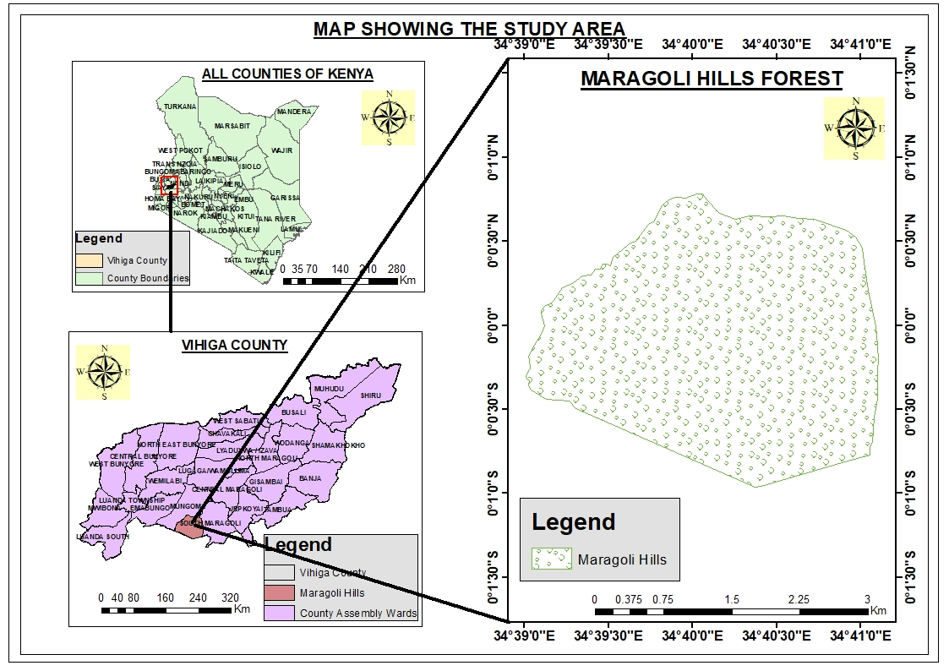

***Figure 2: A map showing the study area***

Maragoli hills forest is located in Vihiga County, Western region of Kenya. Vihiga County lies between longitudes 34°30’ and 35°0’ E and latitudes 0° and 0°15’ N. Its altitude ranges between 1,300 m and 1,800 m above sea level and slopes gently from west to East. It consists of 469.3 ha of exotic tree species, the second largest after Kibiri forest. Mungoma caves, which are also in the same forest, are still treasured by the community as holy places of prayers and a tourist attraction sites in Vihiga County.

According to the National Population and Housing Census (2009), Vihiga County had a population of 554,622, with a population density of 1,078 persons per square km, one of the highest in the country. This is further estimated to grow to 603,856 persons in 2017

(KNBS, 2013). This projected increase in population implies that there will be more pressure on land and other resources supporting livelihoods since the average farm size in the County is 0.4 ha for small scale farming and 3 ha for large scale.

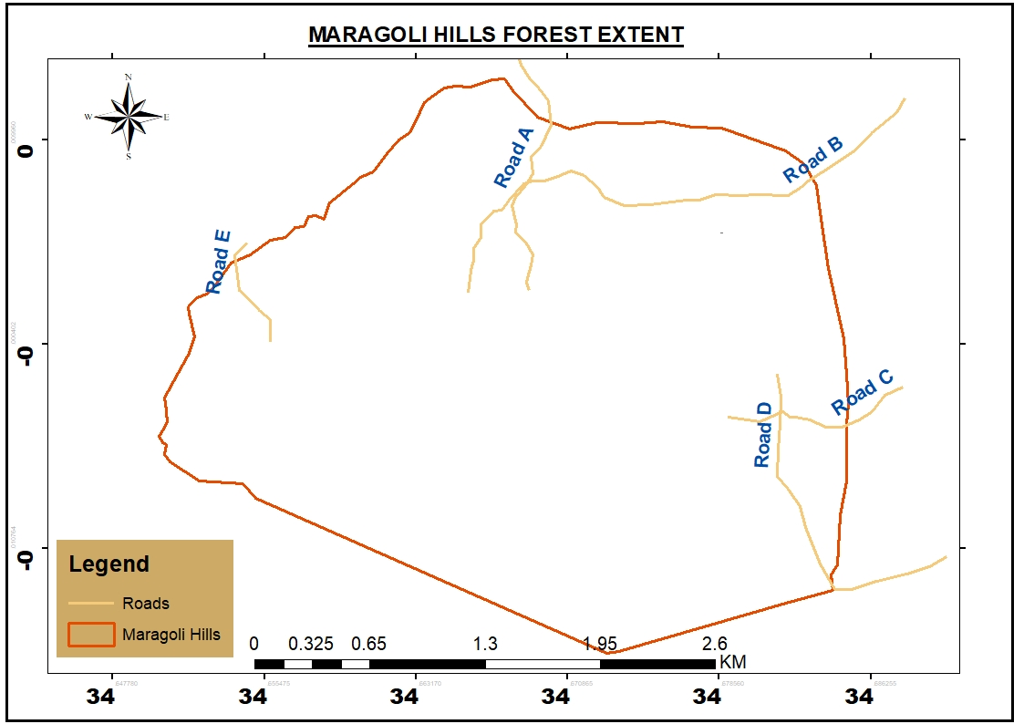

***Figure 3: Map showing Maragoli hills forest and close environs as study area***

## 3.3 Study Population

This includes the larger collection of individuals and objects of focus in the study. For effectiveness in data collection, the targeted population was key informants including the Director of Forestry Vihiga County, Kenya Forest Society (KFS), the environment conservation body NEMA and people within the study area among them area chiefs and village elders. A representative sample study population was therefore made and conclusions drawn from the responses.

## 3.4 Sampling

Systematic sampling was administered where individuals were be selected at regular intervals from the sampling frame to allow adequate sampling size.

## 3.4.1 Sampling Frame

The sample frame included all members in the target group (Director of Forestry, KFS, NEMA representative, chiefs, village elders, neighbouring residents to the study area) and exclude the non-members. It will also include accurate information from selected individuals. The sampling frame thus will be, the Director of Forestry in Vihiga County and KFS.

## 3.4.2 Sampling Procedure

Steps in Systematic Sampling

1. Definition of target population
2. Finding ideal sample size
3. Assigning numbers to every sample member
4. Calculating the sampling interval, i= N/n where is N= Population, n= sample size
5. Selecting random starting point
6. Selecting sample size that can be repeated at regular intervals

With a target population of 100 respondents, a sample size of 10 members will be selected and assigned numbers from 1-100 with 1 as the starting number, therefore;

i= 100/10

Sampling interval (i) =10; to find the sampling size, add the random starting point to the sampling interval. According to (Hayes, 2020), systematic sampling is still thought of as being random if the periodic interval is predetermined and the starting point is chosen at random.

## 3.5 Data Collection

With the aid of GIS and RS technologies, this study made use of both quantitative and qualitative data collection methods by proceeding for data collection in Maragoli hills forest.

***Figure 4: Diagram showing Data Collection Methods***

## 3.5.0 Primary Data

Was collected through conducting of simple Questionnaire surveys, Key Informant Interviews (KII) and Observation methods.

## 3.5.1.1 Surveys

This was a set of written questions with a choice of answers devised for the purposes of study. Questionnaires were used to obtain information from the members of the public to query about knowledge of any noticeable change on Maragoli forest, factors leading to the change and impacts following the changes to the environment.

## 3.5.1.2 Interviews

It is a mechanism to help the interviewer conduct an interview. It was used to interview the respective key informants.

## 3.5.1.3 Observation

This method was employed to collect data on the natural setting and current situation of the forest as well as going on activities. The type of land use and land cover adjacent and inside the forest, ground truthing and taking notes will be achieved by use of this method. Alongside this method, photographs were taken to emphasize on the current situation of the forest and allow imagination, emotions and thoughts about the situation.

## 3.5.2 Secondary data

## 3.5.2.1 Satellite Imagery

For quantitative data, GIS and RS technologies were implied to first download Landsat satellite images from the from United States Geological Survey (USGS) official website (earthexplorer.usgs.gov) with minimum cloud cover. The images ranged from 1985, 1995, 2015 and 2020 to analyse the changes that have transpired on the the Maragoli Hills Forest.

## 3.6 Data Analysis

With data analysis being the process of modelling, adjusting and transforming data with the goal of highlighting essential information, suggesting conclusions, and supporting decision making, it has various facets and approaches, encompassing vast techniques under a variety of names, in different business, science, and social science domains. Therefore, the following techniques were used to analyse the data;

## 3.6.1 Image preprocessing

Following (Churches, Wu, Weng, & Lilleland, 2017), Landsat imagery pre-processing and supervised classification methods were performed for forest cover change detection techniques that involves use of multi-temporal datasets to discriminate areas of land cover change between dates of imaging as of (Garai & Narayana, 2018).

## 3.6.2 **Supervised** Image classification

For land use land cover, the images were then classified into four major LULC classes; Human Settlement, Vegetation comprising of the general vegetation and agricultural activities such as crop farming, Forest and Bare Land inclusive of bare soil and rocky surfaces prevalent in Maragoli hills forest.

## 3.6.3 Forest cover change detection

Just like (Dalmiya & Stehman, 2019). (Othow & et, 2017) Used remote sensing change detection techniques to analyse the rate of LULCC with emphasis on forest cover change in Gog district of Gambella Regional State in Ethiopia, this technique was employed to detect changes that have occurred on Maragoli hills forest. This was done by overlaying LULC images of two different respective years from 1985 to 2020 and running the geo-processing tool specifically using the intersect tool in ArcGIS 10.5 to show areas where changes have taken place pointing exactly the type of change that has occurred by illustrating the shift from one LULC to another and pointing out the total area and percentage of the change. Later, maps were produced to show changes.

# CHAPTER FOUR

# FINDINGS AND DISCUSION

## 4.0 Introduction

This chapter bestow findings and discussions of data collected from field and satellite images from Landsat. Themes along which analysis was done majorly focussed on the objectives of the study formulated from research questions. In this chapter, findings from both the respondents and satellite data are presented while greatly encompassing the prowesses of remote sensing technology. Responses of different forest stakeholders are presented and their voices recognized views, experiences and observations during interviews and data collection process are also inclusive in this chapter. Below is generalized information about respondents and their respective responses.

|  |  |  |  |  |  |  |  |  |
| --- | --- | --- | --- | --- | --- | --- | --- | --- |
| **Gender * Occupation Cross-tabulation** | | | | | | | | |
|  | | | Occupation | | | | | Total |
| Business person | Employed | Farmer | Quarryman | Unemployed |
| Gender | Female | Count | 11 | 6 | 14 | 3 | 5 | 39 |
| % within Gender | 28.2% | 15.4% | 35.9% | 7.7% | 12.8% | 100.0% |
| % within Occupation | 39.3% | 40.0% | 41.2% | 23.1% | 50.0% | 39.0% |
| % of Total | 11.0% | 6.0% | 14.0% | 3.0% | 5.0% | 39.0% |
| Male | Count | 17 | 9 | 20 | 10 | 5 | 61 |
| % within Gender | 27.9% | 14.8% | 32.8% | 16.4% | 8.2% | 100.0% |
| % within Occupation | 60.7% | 60.0% | 58.8% | 76.9% | 50.0% | 61.0% |
| % of Total | 17.0% | 9.0% | 20.0% | 10.0% | 5.0% | 61.0% |
| Total | | Count | 28 | 15 | 34 | 13 | 10 | 100 |
| % within Gender | 28.0% | 15.0% | 34.0% | 13.0% | 10.0% | 100.0% |
| % within Occupation | 100.0% | 100.0% | 100.0% | 100.0% | 100.0% | 100.0% |
| % of Total | 28.0% | 15.0% | 34.0% | 13.0% | 10.0% | 100.0% |

***Table 2: A table showing cross- tabulation of gender and occupation of the respondents***

From the tables above, there was a total of 100 respondents both male and female in different career occupations. A total of 39% female and 61% male respondents engaging in various economic activities such as 28% business persons, 15% employed by either government or the county government, 34% indulging in farming activities including crop production and livestock keeping, 13% quarrymen harvesting ballast and murram whilst 10% of the respondents were unemployed. Below is a bar chart showing the occupational capacities of the respondents both male and female.

***Figure 5: A bar chart showing the occupational capacities of the respondents***

A Chi-square test was run to enable comparison between the observed and expected frequencies objectively to determine difference between observed and expected data due to chance or relationships between gender and occupational status as it not always is possible to determine by looking if they are different enough to be statistically significant.

|  |  |  |  |
| --- | --- | --- | --- |
| **Chi-Square Tests** | | | |
|  | Value | df | Asymp. Sig. (2-sided) |
| Pearson Chi-Square | 1.969a | 4 | .741 |
| Likelihood Ratio | 2.061 | 4 | .725 |
| N of Valid Cases | 100 |  |  |
| a. 1 cells (10.0%) have expected count less than 5. The minimum expected count is 3.90. | | | |

***Table 3: A table showing a Chi-Square Test of gender and occupation of the respondents***

The Chi-Square test table shows statistics to demonstrate the relationship between gender and occupation of the respondents. It thus shows the difference between the observed and expected counts if there was no relationship at all in the population.

## 4.1 Objective 1: Identification of LULC classes and Forest Cover Change Extent among classes

This objective was arrived at by analysing various satellite images of 1985, 1995, 2015 and of 2020. The results of images was complimented by questions that were asked during interviews concerning changes that have been observed. This was a success through first identifying major LULC and finding the change from one class to another.

## 4.1.1 Land Use Land Cover classes for Maragoli Hills Forest Cover

The total area of Forest under study was 8.7 Km2 and spatial analysis was carried out to describe land cover change patterns and overall land-use changes with time. Forested areas, Vegetation, Human settlement areas and Bare land/soil were the major land use and land cover classes of the area of study to identify the land use land cover changes over time. The following maps shows the spatial coverage of four main land use land cover classes within forest reserve in 1985, 1995, 2015 and 2020.

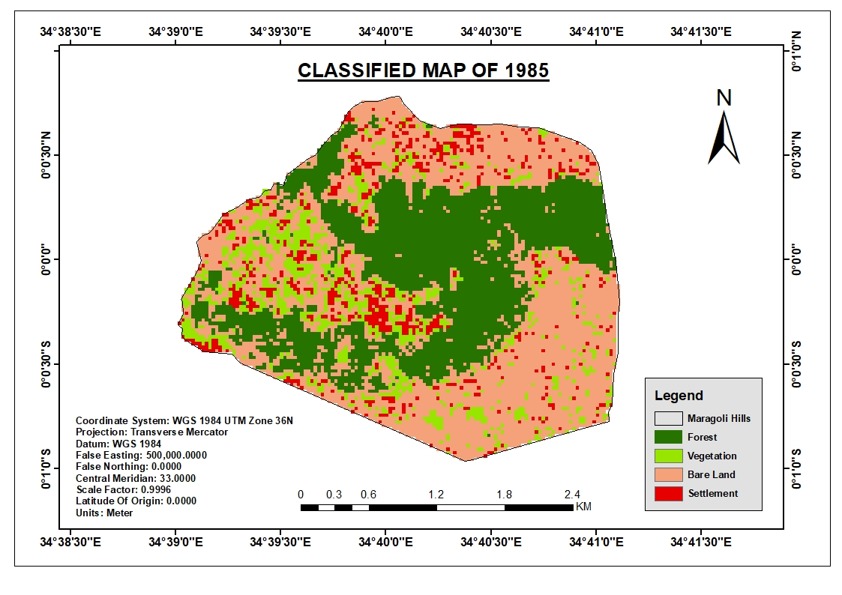

***Figure 6: A map showing distribution of LULC classes of Maragoli forest, 1985***

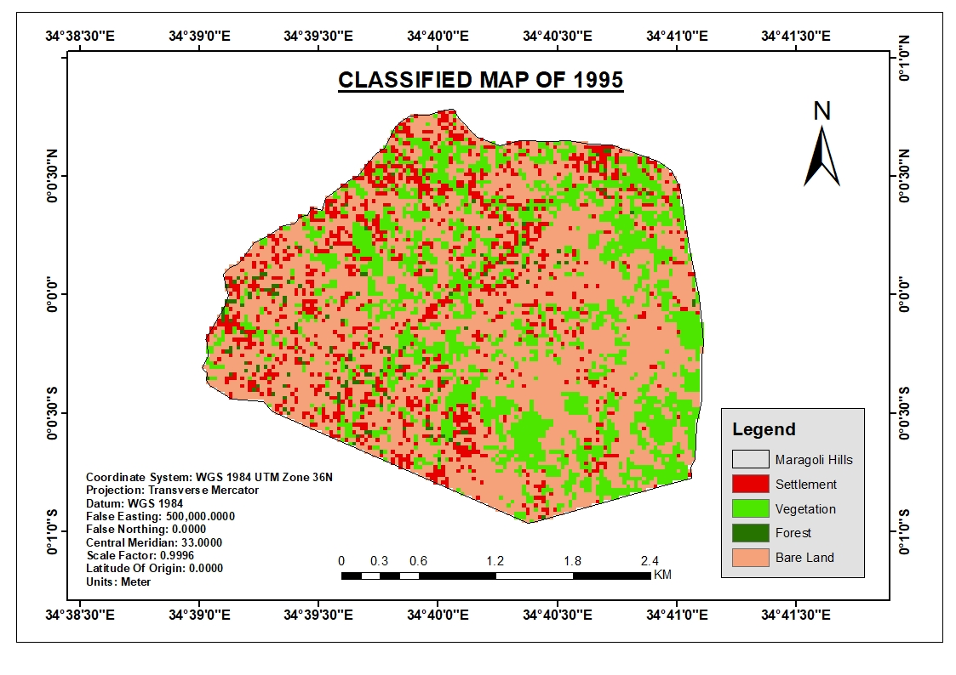

***Figure 7: A map showing LULC classes of Maragoli forest, 1995***

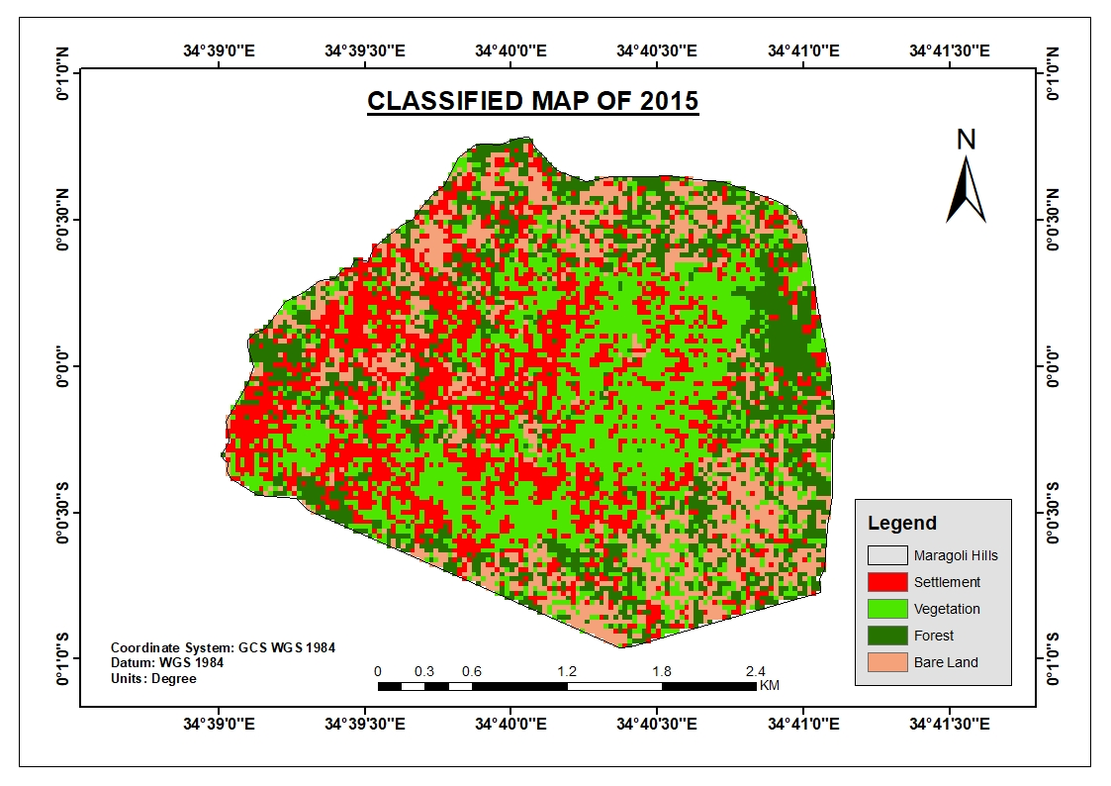

***Figure 8: A map showing LULC classes of Maragoli forest, 2015***

**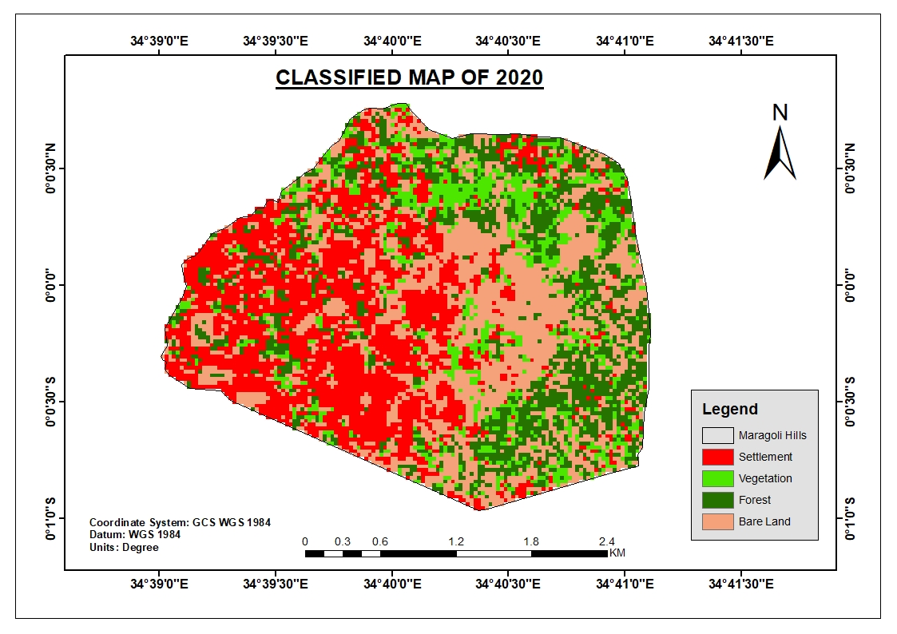*Figure 9: A map showing LULC classes of Maragoli forest, 2020***

The above supervised classified maps of Maragoli Forest of 1985, 1995, 2015 and 2020 depicts distribution of Land Use Land Cover classes where evidently, one class replaces the other year by year as time goes. This is also emphasised by the following bar chart.

***Figure 10: A column chart showing distribution of LULC classes for Maragoli Hills forest.***

The below table thus summarises the above information on the distribution of LULC, area of coverage and total percentage of each LULC of the area of study.

|  |  |  |  |  |  |  |  |  |
| --- | --- | --- | --- | --- | --- | --- | --- | --- |
| **LULC** | **1985** | | **1995** | | **2015** | | **2020** | |
| **Area (km2)** | **%** | **Area (km2)** | **%** | **Area (Km2)** | **%** | **Area (km2)** | **%** |
| Settlement | 0.66 | 8% | 1.19 | 14% | 2.48 | 28% | 2.78 | 32% |
| Vegetation | 1.09 | 12% | 2.46 | 28% | 2.80 | 32% | 1.12 | 13% |
| Forest | 3.03 | 35% | 0.13 | 1% | 1.90 | 22% | 1.88 | 21% |
| Bare Land | 3.987 | 45% | 4.99 | 57% | 1.59 | 18% | 2.99 | 34% |
| TOTAL | 8.77 | 100% | 8.77 | 100% | 8.77 | 100% | 8.77 | 100% |

***Table 4: A table summarising LULC classification with total area and percentage of each class from the total forest area.***

The above table shows a summary of LULC classification by showing the areas and percentage of every LULC in 1985, 1995, 2015 and 2015. An analysis thus depicts that Human settlement increased steadily from a low 8% in 1985, a 6% increase in 1995, a double rise to 28% in 2015 and reaching its high of 32% of the total area of study in 2020. General Vegetation almost retained its portion as it is observed that it occupied 12% of the area in 1985 and rose to a 13% in 2020. However, Vegetation rose to 28% of the total area in 1995 and shot to its highest by a 4% increase in 2015 then later deteriorating to maintain a fair 13% in 2020. Forests occupy a stable 35% in 1985, diminishes to almost nothing in a span of 10 years to occupy a mere 1% in 1995, staggers back to its feet to occupy 22% of the total area in 2015 and stumbles to a 1% fall in 2020 to occupy 21% of the area of study. Bare Land/soil occupies the largest portion by snatching a stable 45% of the study area in 1985, rises to a highest 57% in 1995, later falls to 18% and rises by 16% to command a 34% occupancy of the area in 2020.

# 4.1.2 Accuracy Assessment

With a classified image or change detection map needing to be compared against reference data that is assumed to be true by picking reference points in the field or secondary data such as Google Earth, to assess its performance and quantify its accuracy according to (Foody, 2002). The process was used to estimate the accuracy of image classification by comparing the classified map with Google earth pro imagery. Therefore, full accuracy assessment needs to include the Overall accuracy, User Accuracy, and Producer Accuracy had investigated using the Kappa coefficient as below for supervised classification.

|  |  |  |  |  |  |  |  |  |
| --- | --- | --- | --- | --- | --- | --- | --- | --- |
| **Land Cover Class** | **1985** | | **1995** | | **2015** | | **2020** | |
| **Users Accuracy** | **Producer Accuracy** | **Users Accuracy** | **Producer Accuracy** | **Users Accuracy** | **Producer Accuracy** | **Users Accuracy** | **Producer Accuracy** |
| **Settlement** | **74.00** | **78.00** | **68.00** | **60.00** | **75.00** | **70.00** | **78.00** | **80.00** |
| **Vegetation** | **72.00** | **85.00** | **72.00** | **80.00** | **83.00** | **60.00** | **65.00** | **72.00** |
| **Forest** | **90.00** | **90.00** | **83.00** | **83.00** | **79.00** | **81.00** | **83.00** | **83.00** |
| **Bare Land** | **90.00** | **92.00** | **87.00** | **90.00** | **81.00** | **74.00** | **77.00** | **72.00** |
| **Overall Accuracy** |  | **86.25** |  | **78.25** |  | **71.25** |  | **76.75** |
| **Kappa Statistics** |  | **83.25** |  | **75.55** |  | **69.20** |  | **73.25** |

***Table 5: Summary of Accuracy Assessment from 1985-2020***

## 4.2.1 Overall accuracy

This accuracy gives the overall results of the confusion matrix. It is calculated by dividing the total number of correct pixels (diagonal values) by the total number of pixels in the confusion matrix. According to (Anderson, 1976), the minimum accuracy value for reliable land cover classification is 85 %. On the other hand, accuracy levels are accepted by users may not acceptable by other users for a certain task (Geremew, 2013). 8.1.2.

## 4.2.2 Kappa coefficient (KC)

The Kappa statistic was used to measure the agreement between two sets of categorizations of a dataset (Table 1). And used to estimate the accuracy of predictive models by measuring the agreement between the predictive model and a set of field surveyed sample points (Moriasi et al., 2007).

## 4.1.3 Forest Cover Change Detection Analysis and Features Displacement

The land use and land cover change detection based on remote sensing images have been widely applied in research for LULC, natural resource management and environment monitoring & protection (Zhang et al., 2014). The percentage area of each land cover class derived from supervised classified images for each year separately using Arc GIS 10.5.A careful assessment of the Land Use Land Cover classes portrays changes where one class replaces the other and vice-verse as time goes. Results were obtained through geo-processing analysis under intersect tool, by overlaying and comparing classified maps of different years to yield the following maps showing how features were displaced and replaced from 1985 to 2020.

## 4.1.3.1 LULC Changes 1985-1995

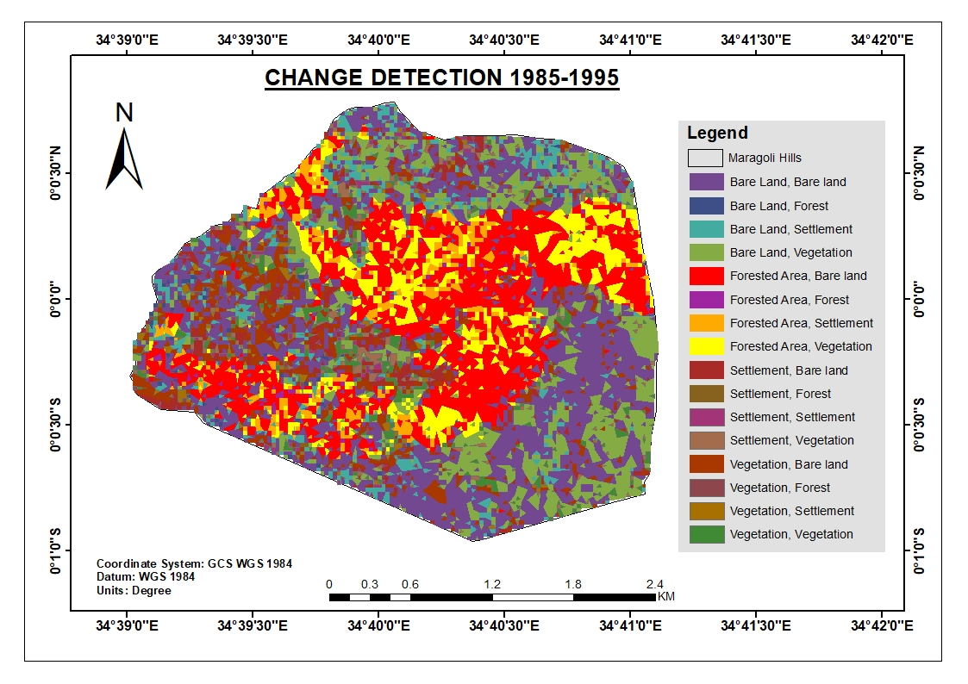***Figure 11: A map showing LULC changes from 1985-1995***

The above map depicts changes of one LULC class to another, it is observed that forest drastically reduced by changing to bare land and general vegetation. The following tables and charts summarises the total changes that took place in a span of ten years.

|  |  |  |
| --- | --- | --- |
| **LULC Change 1985-1995** | **Area** | **%** |
| Bare Lands - Bare Land | 2.28 | 26% |
| Bare Lands - Forest | 0.05 | 1% |
| Bare Lands - Settlement | 0.47 | 5% |
| Bare Lands - Vegetation | 1.24 | 14% |
| Forest - Bare Land | 1.89 | 22% |
| Forest - Forest | 0.04 | 0% |
| Forest - Settlement | 0.41 | 5% |
| Forest - Vegetation | 0.73 | 8% |
| Settlement - Bare Land | 0.36 | 4% |
| Settlement - Forest | 0.01 | 0% |
| Settlement - Settlement | 0.10 | 1% |
| Settlement - Vegetation | 0.16 | 2% |
| Vegetation - Bare Land | 0.60 | 7% |
| Vegetation - Forest | 0.02 | 0% |
| Vegetation - Settlement | 0.14 | 2% |
| Vegetation - Vegetation | 0.27 | 3% |
| **Grand Total** | **8.77** | **100%** |

***Figure 12 & Table 6: Bar chart and table showing extent, total percentage and area of forest cover changes from 1985-1995***

The above chart and table shows the transitional shift of each land use land cover from one class to another depicting the exact area and percentage of the total area change.

|  |  |  |  |  |  |  |
| --- | --- | --- | --- | --- | --- | --- |
| **LULC** | **1985** | | **1995** | | **Area change** | **Change %** |
| **Area (km2)** | **%** | **Area (km2)** | **%** |
| Settlement | 0.662157 | 8% | 1.194957 | 14% | 0.5328 | 6% |
| Vegetation | 1.0863 | 12% | 2.4588 | 28% | 1.3725 | 16% |
| Forest | 3.0303 | 35% | 0.1287 | 1% | -2.9016 | -33% |
| Bare Land | 3.987 | 45% | 4.9833 | 57% | 0.9963 | 11% |
| TOTAL | 8.765757 | 100% | 8.765757 | 100% | 0 | 0% |

***Table 7: A table showing a summary of LULC changes from 1985-1995***

The above table thus summarises the total area of change of all the LULC classes while illustrating the type of change (increase/decrease) in area and percentage from the initial total area.

***Figure 13: Bar chart showing LULC changes from 1985-1995***

The above bar chart and table illustrates the changes that took place within the study area, they elucidates that human settlement increased slightly to occupy 14% of the total area from 8%, general vegetation rose by 16% to sit on 28% of the area from 12%. However forest areas drastically decreased to almost an extinction by a 33% decrease to cover only 1% of the area under study while bare lands increased by 11% to command 57% from 45% of the total area.

## 4.1.3.2 LULC Changes 1995-2015

Below are maps, tables and charts visualizing and showing the extent of LULC changes that transpired in a span of 10years on Maragoli Hills forest.

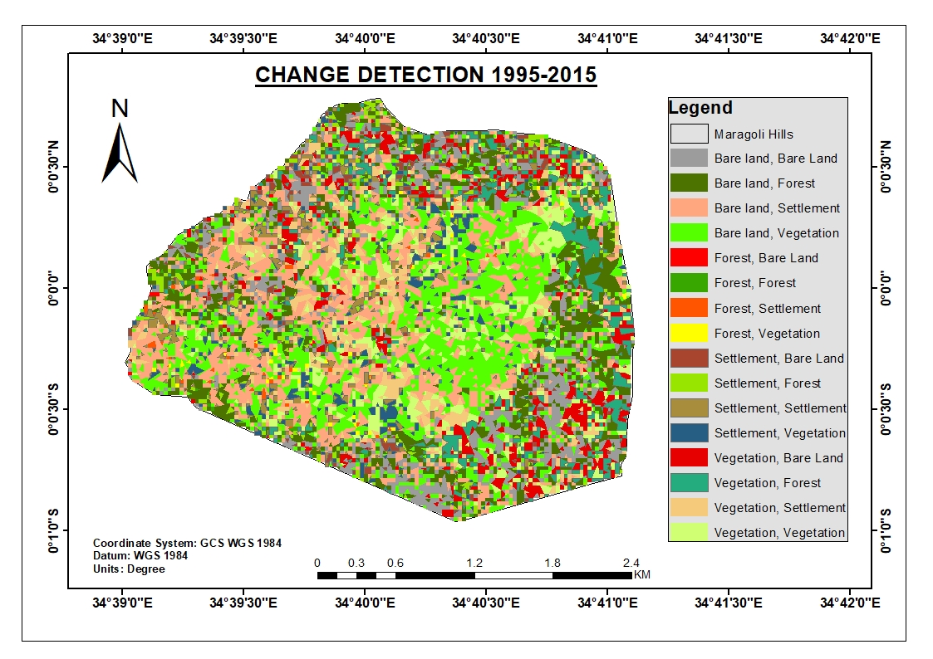

***Figure 14:*** ***A map showing LULC changes from 1995-2015***

The above maps conjures the LULC changes that betide Maragoli Hills forest depicting the shift of one LULC class to another by displacement or replacement. From the map, LULC classes shifts such as Forest changing to Settlement or general vegetation as well as other changes. Human settlement rises by 15% from 14%, general vegetation rises by 4% to enthral 32% of the total area while forest areas rise by 20% from 1% and bare lands reduce severely by 39% to engross only 18% of the area from 59%. The table below expounds the changes in figures. Total areas of LULC class shift are shown as below in the bar charts and tables.

|  |  |  |
| --- | --- | --- |
| **LULC Change 1995-2015** | **Area** | **%** |
| Bare Land - Bare Land | 0.88 | 10% |
| Bare Land - Forest | 1.06 | 12% |
| Bare Land - Settlement | 1.47 | 17% |
| Bare Land - Vegetation | 1.73 | 20% |
| Forest - Bare Land | 0.01 | 0% |
| Forest - Forest | 0.03 | 0% |
| Forest - Settlement | 0.04 | 0% |
| Forest - Vegetation | 0.04 | 0% |
| Settlement - Bare Land | 0.19 | 2% |
| Settlement - Forest | 0.24 | 3% |
| Settlement - Settlement | 0.35 | 4% |
| Settlement - Vegetation | 0.34 | 4% |
| Vegetation - Bare Land | 0.51 | 6% |
| Vegetation - Forest | 0.57 | 6% |
| Vegetation - Settlement | 0.64 | 7% |
| Vegetation - Vegetation | 0.68 | 8% |
| **Grand Total** | **8.77** | **100%** |

***Figure 15 & Table 8: A bar chart and table showing the areas of each LULC class change***

The above bar chart and table illustrates the changes from one LULC to another with respect to the exact area and percentage of shift to the other class.

|  |  |  |  |  |  |  |
| --- | --- | --- | --- | --- | --- | --- |
| **LULC** | **1995** | | **2015** | | **Area change (km2)** | **Change %** |
| **Area (km2)** | **%** | **Area (Km2)** | **%** |
| Settlement | 1.194957 | 14% | 2.475657 | 28% | 1.2807 | 15% |
| Vegetation | 2.4588 | 28% | 2.7999 | 32% | 0.3411 | 4% |
| Forest | 0.1287 | 1% | 1.899 | 22% | 1.7703 | 20% |
| Bare Land | 4.9833 | 57% | 1.5912 | 18% | -3.3921 | -39% |
| TOTAL | 8.765757 | 100% | 8.765757 | 100% | 0 | 0% |

***Table 9: A table showing LULC changes from 1995-2015***

The table summarises the total area and percentage of change with the nature of change per each LULC class from its initial state.

The below bar chart therefore visualises the LULC changes to show the increase or decrease of each LULC within the span of 10 years.

***Figure 16: A bar chart visualizing the change of LULC classes from 1995-2015***

## 4.1.3.3 LULC Changes 2015-2020

Maps, tables and charts showing changes in LULC from 2015-20 are as follows:

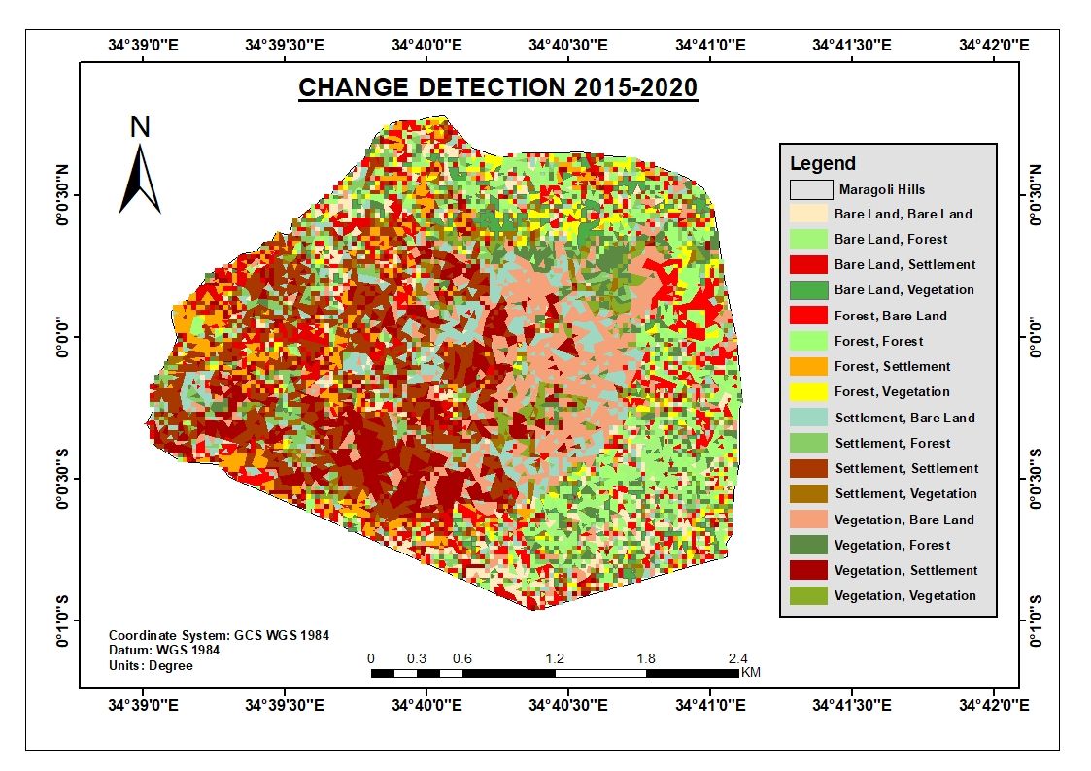

***Figure 17: A map showing change detection from 2015-2020***

The above map shows the shift of one LULC from one class to another. Patterns and exact area of change are illustrated by bar chart and table below.

|  |  |  |
| --- | --- | --- |
| **LULC Change 2015-2020** | **Area** | **%** |
| Bare Land - Bare Land | 0.45 | 5% |
| Bare Land - Settlement | 0.36 | 4% |
| Bare Land - Forest | 0.50 | 6% |
| Bare Land - Vegetation | 0.29 | 3% |
| Forest - Bare Land | 0.58 | 7% |
| Forest - Settlement | 0.48 | 5% |
| Forest - Forest | 0.55 | 6% |
| Forest - Vegetation | 0.27 | 3% |
| Settlement - Bare Land | 0.79 | 9% |
| Settlement - Settlement | 1.11 | 13% |
| Settlement - Forest | 0.37 | 4% |
| Settlement - Vegetation | 0.23 | 3% |
| Vegetation - Bare Land | 1.13 | 13% |
| Vegetation - Settlement | 0.92 | 10% |
| Vegetation - Forest | 0.44 | 5% |
| Vegetation - Vegetation | 0.29 | 3% |
| **Grand Total** | **8.77** | **100%** |

***Figure 18 & Table 10: Bar chart and table showing LULC class and area changes from 2015-2020***

The above bar chart and table shows the exact area and percentage of the total area of shift from one LULC to another. The table below illustrates the broad changes in area, percentage and nature of change.

|  |  |  |  |  |  |  |
| --- | --- | --- | --- | --- | --- | --- |
| **LULC** | **2015** | | **2020** | | **Area change (km2)** | **Change %** |
| **Area (km2)** | **%** | **Area (km2)** | **%** |
| Settlement | 2.475657 | 0.28 | 2.779857 | 0.3171 | 0.3042 | 0.03 |
| Vegetation | 2.7999 | 0.32 | 1.1214 | 0.1279 | -1.6785 | -0.19 |
| Forest | 1.899 | 0.22 | 1.8774 | 0.2142 | -0.0216 | 0.00 |
| Bare Land | 1.5912 | 0.18 | 2.9871 | 0.3408 | 1.3959 | 0.16 |
| TOTAL | 8.765757 | 1.00 | 8.765757 | 1 | 0 | 0.00 |

***Table 11: A table showing total area and percentage decrease/increase in LULC changes from 2015-2020***

The above table envisages the total area of change per each LULC, percentage of the total area changed and the type of the change either increase or decrease of each LULC.

***Figure 19: Bar chart showing LULC changes from 2015-2020***

The above bar chart visualises the transformation of every LULC by either decreasing or increasing in a span of 10 years.

**4.1.3.4 LULC Changes 1985-2020**

A summary of the extent of change on forest cover is illustrated by the below maps, charts and tables.

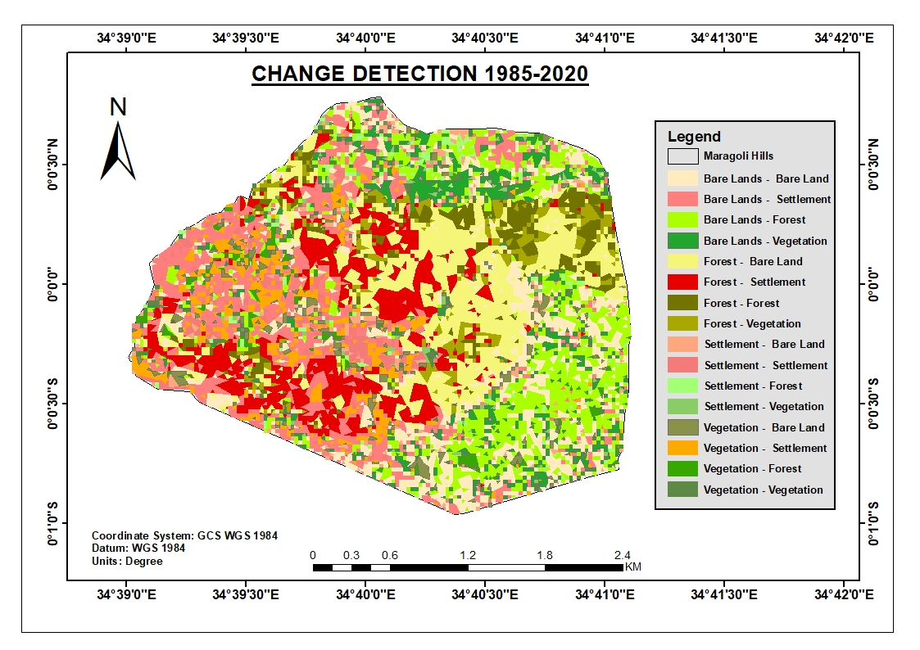

***Figure 20: A map showing LULC class changes from 1985-2020***

|  |  |  |
| --- | --- | --- |
| **LULC Change 1985-2020** | **Area** | **%** |
| Bare Lands - Bare Land | 1.19 | 14% |
| Bare Lands - Settlement | 1.12 | 13% |
| Bare Lands - Forest | 1.13 | 13% |
| Bare Lands - Vegetation | 0.60 | 7% |
| Forest - Bare Land | 1.31 | 15% |
| Forest - Settlement | 1.00 | 11% |
| Forest - Forest | 0.43 | 5% |
| Forest - Vegetation | 0.33 | 4% |
| Settlement - Bare Land | 0.17 | 2% |
| Settlement - Settlement | 0.26 | 3% |
| Settlement - Forest | 0.14 | 2% |
| Settlement - Vegetation | 0.06 | 1% |
| Vegetation - Bare Land | 0.28 | 3% |
| Vegetation - Settlement | 0.49 | 6% |
| Vegetation - Forest | 0.17 | 2% |
| Vegetation - Vegetation | 0.09 | 1% |
| **Grand Total** | **8.77** | **100%** |

***Figure 21 & Table 12: Bar Chart and table showing summary and extent of LULC changes form 1985-2020***

The above bar chart and table broadly summarises the change detection process of Maragoli hills forest from 1985-2020 by illustrating the exact area and percentage of shift from one LULC to another to identify the extent of change. The table below shows a summary of the process.

|  |  |  |  |  |  |  |
| --- | --- | --- | --- | --- | --- | --- |
| **LULC** | **1985** | | **2020** | | **Area change** | **Change %** |
| **Area (km2)** | **%** | **Area (km2)** | **%** |
| Settlement | 0.66 | 0.08 | 2.78 | 0.32 | 2.12 | 24% |
| Vegetation | 1.09 | 0.12 | 1.12 | 0.13 | 0.04 | 1% |
| Forest | 3.03 | 0.35 | 1.88 | 0.21 | -1.15 | -14% |
| Bare Land | 3.99 | 0.45 | 2.99 | 0.34 | -1.00 | -11% |
| TOTAL | 8.77 | 1.00 | 8.77 | 1.00 | 0.00 | 0.00 |

***Table 13: Table showing LULC change extent from 1985-2020***

The table above bestow the total area and percentage of every LULC change depicting the type of change either increase or decrease in area and percentage of every LULC from 1985-2020. The following table breaks down the change process at every stage whilst summarising the transformation.

## 4.1.4 Change Detection Analysis summary

|  |  |  |  |  |  |  |  |  |  |  |
| --- | --- | --- | --- | --- | --- | --- | --- | --- | --- | --- |
| **LULC** | **1985** | | **1995** | | **2015** | | **2020** | | **Change**  **(1985-2020)** | |
| **Area (KM2)** | **%** | **Area (KM2)** | **%** | **Area (KM2)** | **%** | **Area (KM2)** | **%** | **Area (KM2)** | **%** |
| Settlement | **0.66** | **8%** | **1.19** | **14%** | **2.48** | **28%** | **2.78** | **32%** | **2.12** | **24%** |
| Vegetation | **1.09** | **12%** | **2.46** | **28%** | **2.80** | **32%** | **1.12** | **13%** | **0.04** | **1%** |
| Forest | **3.03** | **35%** | **0.13** | **1%** | **1.90** | **22%** | **1.88** | **21%** | **-1.15** | **-14%** |
| Bare Land | **3.99** | **45%** | **4.99** | **57%** | **1.59** | **18%** | **2.99** | **34%** | **-1.00** | **-11%** |
| TOTAL | **8.77** | **100%** | **8.77** | **100%** | **8.77** | **100%** | **8.77** | **100%** | **0** | **0%** |

***Table 14: Table showing summary of change extent in each LULC from 1985-2020***

The above table wraps up the occurrence of change events from one LULC shifting to another, showing the exact shift area in (Km2) as well as percentage of the total area. The exact changes are also summarized and the type of change (negative/positive) indicated.

## 4.2 Objective 2: FACTORS CONTRIBUTING TO MARAGOLI HILLS FOREST COVER CHANGE

This bourn was to identify factors contributing to LULC changes from 1985-2020 which was achieved through key informant interview and administering questionnaires to residents living nearby to the forest reserve. The following table illustrates distribution of factors contributing to forest cover change from a sample of 100 respondents.

|  |  |  |
| --- | --- | --- |
| **Factors** | **Respondents** | **%** |
| Illegal Logging | 58 | 58% |
| Agricultural Expansion | 15 | 15% |
| Encroachment | 13 | 13% |
| Population Growth | 8 | 8% |
| Fuel wood Harvesting | 6 | 6% |

***Table 15: Table showing factors contributing to forest cover change and responses on Maragoli hills forest from 1985-2020***

## 4.2.1 Illegal logging

As indicated from the table, illegal logging was the senior most driver to Maragoli Hills forest cover change as highlighted by 58% of the respondents. Respondents voiced that the destruction of the forest was majorly attributed to some “government officials”, where it is said that a one-time area chief decided to uncontrollably cut trees from the forest for sale to his material gain. With other human activities such as logging, charcoal burning and invaders seeking for fencing post left the forest bare and vulnerable to exposure to harsh climatic conditions as well as further destruction from the community thus spearheading the forest cover change leaving about just 1% of forest in 1995.

According to (YALE , 2020) , Illegal logging is actually harvesting of timber from protected areas, felling protected species, or exceeding logging quotas.

The Vihiga County Director of forestry pointed out that illegal logging has persisted to be a threat on Maragoli Hills forest which is orchestrated by community members who have dragged back efforts to restore the affected areas of the forest through uprooting/leaving to dry up of the planted trees. However, a few respondents envisaged that there has been laxity by the Department of Forestry to lead and sustain restoration measures to the forest, with other stakeholders including the local community failing to hire forest guards to protect the forest reserve which has left the forest vulnerable to destruction through theft of the few planted trees therefore the shift in land use and land cover. Below is a picture showing massive cutting of trees in Mungoma to depletion of Maragoli hills forest.

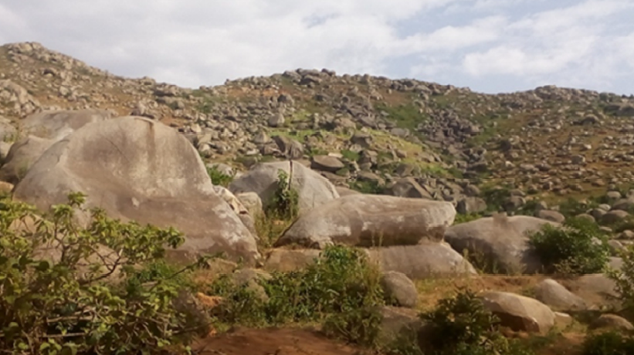

***Image 1: A picture showing Depleted Maragoli forest due to tree cutting in Mungoma.***

The above picture was captured to emphasise observation method of data collection to show a pictorial representation of the current state of the forest following illegal cutting of trees contributing to the forest near depletion.

## 4.2.2Agricultural Expansion

15% of the respondents attributed Maragoli forest cover change to expansion of agriculture which is described as conversion of non-agricultural lands to agricultural lands i.e conversion of forested land to crop land or natural grasslands to pastures. This is evident where following the change detection process, a large portion of forest land shifted to general vegetation which is inclusive of agricultural activities. According to FAO, agriculture causes around 80% of deforestation which is caused by subsequent agriculture in developing countries. Following population pressure, the need to produce more food was thus mounted on forest cover by clearing forested lands to provide room for food production to satisfy the food demand from highly increasing population.

According to (The World Fact book, 2004), population pressure remains a key challenge to maintaining the already fragile ecosystems. It has been observed that about 50% of the population live below the poverty line (less than 1 USD/day) and unemployment is high, estimated at about 40% of the labour force.

Research findings indicated that majority of residents in Vihiga County are famers and crop production is the mainstream economic activity in the County and contributes to approximately 64% of the County’s income. Agricultural activities and livestock keeping have aided increased availability of food for household consumption and the surplus beyond immediate consumption requirements can generate real income for other investments as per (Swift, 1989). Engagement in agriculture employs over 80% of the people in Vihiga. The findings are consistent with UNEP (2002) which classifies Sub-Sahara Africa as agriculturists. Crop production is mainly meant for food sustenance, however, respondents disclosed that most of the produce ended up in the so as to raise extra cash to support families in various respects. Due to diminished farm sizes, average farm yield per unit area is relatively low for most farming households with tea production widely practiced, although in small scale because of shrinking land sizes.

Tea production is a key economic activity as it employs a good percentage of the population directly on-farm by providing casual labour such as weeding the plantations and picking tea leaves or off-farm engagement in the existing Mudete Tea Factory located in Sabatia Sub-County. However, respondents lamented on the threat facing tea production is also under threat because following unfavourable tea prices according to (Dresner, 2002).

## 4.2.3 Encroachment

The advancement of structures, roads, improved paths, utilities and other developments was stated by 13% of the respondents as one of the drivers to forest cover degradation on Maragoli hills forest and other changes. Encroachment was as a result of high rates of unemployment and population growth.

The encroachment was in pursuit of arable agricultural lands food production food and human settlement. Since food production is the main source of income in the county, the community cultivate grounds to produce food for consumption and for commercial purpose thus the growing population greatly increased the urge for more agricultural lands for food production hence forcing the community to cross forest reserve boundaries especially Mungoma for cultivation land.

## 4.2.4 Population growth

This is the increase in the number of people in a population where global population growth is termed to be 1.1% annually. According to the County Profile, Vihiga County maintains a population growth of 2.51% with an annual fertility of 5.1% thus explaining its high population rise. The increasing population thus mounted its pressure on the already shrinking forest land in pursuit for human settlement areas and food production spaces through agriculture to serve the rising population. 8% of the respondents thus articulated forest cover changes on Maragoli forest to the increasing rate of population growth in the county.

## 4.2.5 Fuel-wood harvesting

Collection of fuel wood and building material from rainforests remain to be major causes of deforestation by settlers where it is stated that in just a few months, over 20,000 acres park were cleared to fuel wood and building material (2012). 6% of the respondents linked Maragoli forest cover change to fuel wood harvesting through vast fetching of firewood by individuals for cooking in their households, heavy burning of charcoal both for domestic use and commercial purposes. It was said that trees, woody shrubs and bushes were harvested for fuel wood. One of the respondents who was an area chief pointed out that individuals would normally go deep into the forest to clear indigenous trees believed to produce the best quality of charcoal to burn and sale the charcoal.

Below is a pie chart visualizing the distribution of factors causing forest cover change on Maragoli forest from 1985-2020.

***Figure 22: A Pie Chart showing the Causes of Forest Cover Changes on Maragoli Hills Forest***

## 4.3 Objective 3: IMPACTS OF MARAGOLI HILLS FOREST COVER CHANGE TO THE ENVIRONMENT

Following various aspects of forest cover change, respondents were able to point out a number of impacts following the forest cover changes to the environment. The following table enlists impacts of Maragoli forest cover change to the environment;

|  |  |  |
| --- | --- | --- |
| **Impact** | **Respondents** | **%** |
| Soil Erosion | 46 | 46% |
| Climate Change | 21 | 21% |
| Reduced Rainfall | 13 | 13% |
| Land Degradation/Desertification | 11 | 11% |
| Reduced biodiversity | 9 | 9% |

***Table 16: Table showing impacts and responses of forest cover change on Maragoli forest***

## 4.3.1 Soil Erosion

Soil erosion is the removal of top layer soil caused by wind and water. This process is both natural and man-made where human activities such as tillage in agriculture can cause exposure to these elements. Soils become detached then moved and finally deposited, with top soils being nutrient rich with organic matter which are fertile and requisite for crop production thus their removal negatively impacts agricultural potential of land. Deposition of the soils to other locations causes pollution of water bodies and water courses.

Deforestation is a major cause of soil erosion where trees and their roots provide soil the anchor and shelter from wind and rainfall. Slash and burn deforestation also impacts the environment by introducing volumes of carbon dioxide in the atmosphere.

With the destruction of forest cover, the land is left exposed thus vulnerable to being washed or blown away by heavy rains or wind. Logging and small-scale removal of trees also leaves soil exposed to rain where splashes loosen and dislodge soil particles eroding them and creating impermeable bare surface increasing runoff.

A majority (46%) of the respondents acknowledged that soil erosion has been a challenge following forest cover changes on Maragoli Forest as well as poor farming practices, destruction of vegetation cover also contributing to soil erosion whose further effects have been loss of soil fertility, poor crop yield, and unsustainable livelihoods. This has thus increased quarrying activities as they are predominant in Hamisi, Vihiga and Emuhaya Sub-Counties. Respondents involved in these activities earn a living through employment as casuals or self-employed. In the quarry sites, some respondents work on granitic rocks to produce ballast for local construction works using local tools like masons hammer which is basically very labour intensive.

Sand mining activities are also prevalent along the rivers across the County which as a result of big deposits of sand downstream from erosion upstream due to destruction of the vegetation cover by human activity. Their provision of labour ensures steady, continuous stream of income at different levels to individual households, communities, county and country through payment of taxes by respective firms. It is estimated that approximately 70% of land area in Vihiga County is rocky. This in itself presents both opportunities and challenges for many households in the County. It is an opportunity because the presence of granitic rocks potential has not been exploited to the later. For instance, developing the necessary infrastructure for mining the rocks will trigger a chain reaction that can stimulate key economic activities for many households who may be engaged in the sector. The rocky landscape is a challenge to households because it impedes on the use of, for example, machinery as a physical asset to support livelihoods. Also, rocks because of their physical nature are obstacles to diversification strategies that could cushion many households on natural disasters. It was noticed that quarrymen harvested murram for road and infrastructural construction from rocky areas to depletion as shown in the picture below.

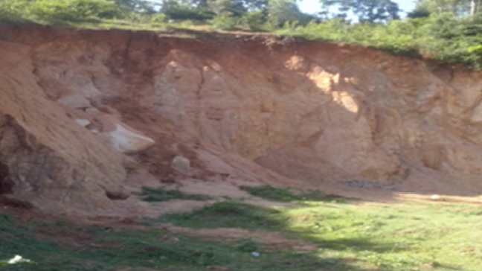

***Image 2: A picture showing depleted murram sites in Vigetse village, Maragoli forest in Vihiga County.***

## 4.3.2 Climate Change

Climate change is characterised by global warming emanating from human activities causing emissions of greenhouse gases resulting to large scale shift in weather patterns. Greenhouse gases such as Carbon dioxide, methane and burning fossil fuels for energy consumption, agricultural activities and deforestation by humans majorly contribute to climate change. Following destabilisation of the earth’s temperature equilibrium, global warming is a challenge due to change in energy balance and temperature change. Increased concentration of greenhouse gases has had significant impacts on humans and the environment, with the decreased forest cover of Maragoli hills, the failure to stabilise climate, regulate ecosystems, protect biodiversity and play the integral role of carbon cycle in absorbing carbon dioxide and producing oxygen which is safe for the environment, temperatures have been observed to have risen beyond normal contributing to desert expansion within Maragoli hills forest as envisaged by 21% of the respondents. With direct and indirect consequences of climate change on the environment including;

* Rising maximum temperatures
* Rising minimum temperatures
* Increase in heavy precipitation ( heavy rain)
* Water crises and hunger and developing countries
* Economic implications relating to climate change
* Increased spread of pests and pathogens
* Loss of biodiversity due to limited adaptability
* Health risks from rising air temperatures and heat waves

Respondents have experienced majority of the above effects of climate change both direct and indirectly and related to them as a result of the capsizing forest cover of Maragoli forest. Other impacts such as occurrence of resistant pests and diseases affecting food and livestock production to farmers in the county have been attributed to climate change. This challenges have thus led residents to indulge in other economic activities to earn a living. It was observed that some had turned to ballast extraction.

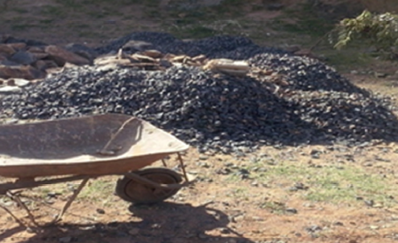

***Image 3: A picture showing local ballast extraction in Vihiga County.***

## 4.3.3 Reduced amounts of Rainfall

Following the reduced Maragoli forest cover, it has been observed that there has been reducing amounts of rainfall as a result of reduced natural recycling moisture from soils which takes place through vegetation and returns as rainfall. According to various studies, when pastures and bare lands replace forests, water recycling gets affected leading to reduction in humidity in the atmosphere which impacts precipitation. Reduced forest cover also leads to increased carbon dioxide in the atmosphere giving rise to global warming that later has adverse effects on the natural water cycle. Deforestation also brings to reality the occurrence of floods due to reduced water holding capacity of soil which is dependent to trees. As the number of trees reduce, the soil profile changes and soil particles held firmly gets disturbed leaving chance to erosion from rainwater and wind.

With crop production bring the mainstream economic activity in the County contributing to approximately 64% of the County’s income, basic grain farming, livestock rearing, tea production, forestry and mining, a good percentage of respondents pointed out that they have had a challenge in crop production as a result of reduced amounts of rainfall and married the main cause to declined forest cover of Maragoli hills forest.

Below is a picture showing tea production as the main economic activity in Vihiga County.

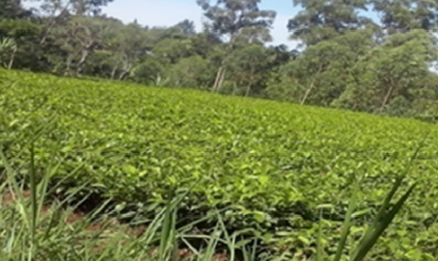

***Image 4: A picture showing Tea farming as a major economic activity in Vihiga County.***

The above picture shows farming as one of the major economic drivers of Vihiga County with tea production of tea as the major type of crop production being practised.

## 4.3.4 Land Degradation/Desertification

Land degradation is articulated by various factors including extreme weather conditions such as drought, human activities that pollute or degrade the quality of soils and land utility. It has effects to food production, livelihoods and provision of other ecosystems, goods and services. Desertification is a type of land degradation where fertile land becomes a desert and unsuitable for agriculture where fertile land becomes a desert and unsuitable for agricultural use. Desertification has a number of impacts to humans such as higher threats of malnutrition from reduced water and food supply, spread of infectious diseases as populations migrate, respiratory diseases caused by atmospheric dust from wind erosion and other pollutants as well as water and food-borne diseases resulting from poor hygiene and lack of clean water.

The rapid expansion and unsuitable management of crop and grazing lands has been a major driver of land degradation contributing to loss of biodiversity, food insecurity, water purification, energy provision and other nature essential to people. 11% of the respondents termed land degradation as an effect of Maragoli hills forest cover change.

## 4.3.5 Reduced biodiversity

9% of the respondents voiced that reduced biodiversity which refers to decline of biological-diversity such as loss of animal species living on trees, lack habitat thus relocate and become extinct. Certain tree species with medicinal and spiritual importance to the community was also said to have been lost during the forest cover changes. Reducing biodiversity also contributes to other impacts including climate change and global warming.

Below is a pie chart representing the impacts of forest cover change on Maragoli forest,

***Figure 23: A pie chart showing impacts of forest cover change on Maragoli hills forest.***

The above pie chart summarises the impacts of forest cover changes on Maragoli hills forest as per the respondents. Soil erosion is indicated to be the senior-most impact according to 46% and desertification the least with 11% of responses respectively.

# CHAPTER FIVE

# CONCLUSION AND RECOMMENDATION

## 5.1 Conclusion

Maragoli hills forest has undergone changes on the identified LULC classes at different scales where human settlement rose by 24% to occupy 32% of the total area thus posing the largest forest cover change as 13% of bare land, 11% of forest land and 6% of general vegetation changed to human settlement with minor changes to other land uses including 2% change to human settlement as well as another 2% to forest land. General vegetation including agricultural activities has greatly reduced to 1% despite shooting to its highest in 2015 following 7% increase from bare lands, 4% from forest land, 1% from human settlement and 6% decrease to human settlement, 3% to bare land and 2% to forest land. Forest land deteriorated by 14% with 13% increase from bare land, 2% from human settlement, 2% from general vegetation and decreases by 15% to bare land, 11% to human settlement, and 4% to general vegetation. Bare lands suffered an 11% decrease following 15% increase from forest land, 2% from human settlement, 3% from general vegetation and 12% decrease to human settlement, 13% to forest land as well as 7% to general vegetation.

The changes were articulated by massive destruction of trees from the forest by some “government officials” according to reliable sources from the field. Extensive population increase rates also has mounted pressure on Maragoli hills forest cover as humans strive to seek settlement areas and arable lands for agricultural activities to cater for the increased demand of food from the growing population to the already shrinking forest land. The table below shows a summary of the extent of change on Maragoli forest cover from 1985-2020;

|  |  |  |
| --- | --- | --- |
| **LULC Change 1985-2020** | **Area(Km2)** | **Percentage %** |
| Bare Lands - Bare Land | 1.19 | 14% |
| Bare Lands - Settlement | 1.12 | 13% |
| Bare Lands - Forest | 1.13 | 13% |
| Bare Lands - Vegetation | 0.60 | 7% |
| Forest - Bare Land | 1.31 | 15% |
| Forest - Settlement | 1.00 | 11% |
| Forest - Forest | 0.43 | 5% |
| Forest - Vegetation | 0.33 | 4% |
| Settlement - Bare Land | 0.17 | 2% |
| Settlement - Settlement | 0.26 | 3% |
| Settlement - Forest | 0.14 | 2% |
| Settlement - Vegetation | 0.06 | 1% |
| Vegetation - Bare Land | 0.28 | 3% |
| Vegetation - Settlement | 0.49 | 6% |
| Vegetation - Forest | 0.17 | 2% |
| Vegetation - Vegetation | 0.09 | 1% |
| **Grand Total** | **8.77** | **100%** |

***Table 17: Table showing extent of forest cover change on Maragoli forest***

The above table bestow a summary of the forest cover change process from 1985-2020 by showing the exact area and percentage of each LULC shifting from one class to another.

Factors contributing to Maragoli forest cover change were identified to majorly be human inflicted as the discovered changes were identified to be caused by human activities including illegal logging of trees by some officials and community members, agricultural expansion of individuals bordering the forest reserve, encroachment, population growth and fuel wood harvesting. This activities targeted particular parts of the forests as certain indigenous trees were sought for logging and charcoal burning to provide the best quality of products in need. Fertile pats of the forest were also preferred to others to support agricultural production including tea farming which was the mainly grown crop. Population growth was identified to have had major contribution to forest cover change following increased human settlement on initially forested land and general vegetation as observed. This therefore points out that humans are harmful to the environment and if left to freely access forest resources, might over use the resources leaving them unavailable for the future generation thus the responsibility of maintaining forest reserves falls back to them to protect forest cover.

The forest cover changes have led to various implications to the environment among them the observable rampant soil erosion and flooding due to lack of trees to hold soil firmly to protect it from being washed away thus the left infertile soil that does not sustainably support agriculture according to some farmers. Lack of maintaining the ecological balance between carbon dioxide and oxygen by forest trees has contributed to climate change which has been experienced in a number of ways such as changes due to increased minimum and maximum temperatures, health risks from air temperatures, occurrence of pests and pathogens affecting both agriculture and livestock keeping. There has also been reduced amounts of rainfall to support agriculture, land degradation and reduced biodiversity as trees species providing habitat to some wild animals have been destroyed thus animals had to migrate therefore losing both known species. If these forest cover changes are not properly mitigated, there could be adverse effects such as including food and huge economic loss in future.

## 5.2 Recommendation

The Government and Forest Department should survey and categorize forest areas with proper delimitation to prevent anyone from damaging reserved areas as well as passing acts that conserve forests. Administrative settings for forest management should also be set up to be able to protect forest areas against uncontrolled human settlement and unwanted land use dynamics through land planning and management.

Through enacting of stringent measures by the County government and Kenya Forestry Service (KFS) to prevent forest clearance and banning clear cutting of forests for any reasons as well as drafting harsh penalties to offenders of deforestation to curb any illegal logging and other causes of deforestation.

Encouraging community reforestation programs by local residents, volunteers, schools and government at various levels through planting trees on degraded land to reduce adverse effects of deforestation such as soil erosion, climate change and soil water holding capacity to increase amounts of the reduced rainfall being experienced. This should help in strengthen socials bonds, regenerate degraded land and other vast advantages such as discouraging any further deforestation.

# REFERENCES

Amos, T. (2008). Pragmatic Research Design: an Illustration of the Use of the Delphi Technique. *The Electronic Journal of Business Research Methods* , 95-102.

(Bernard Charlery de la Masselière, F. B. (2018, October 17). Mountains and urbanization in East Africa. *Hal Archives-Ouvertes*, 3-13.

Canty, M. J. (2009). *IMAGE ANALYSIS, CLASSIFICATION, and CHANGE DETECTION in REMOTE SENSING .* CRC Press.

Cherry, K. (2019, September 17). *VeryWell Mind*. Retrieved from The Pros and Cons of Longitudinal Research: https://www.verywellmind.com/what-is-longitudinal-research-2795335

IPCC. (2019). GLOBAL WARMING OF 1.5 ºC. *Framing and Context*, 51-56.

KWS. (2003). *Changes in the state of conservation of Mt. Kenya forests: 1999 - 2002.* Kul Graphics Ltd

NEMA. (2012). *Forest Cover .* Nairobi.

NOAA. (2020). *What is the difference between land cover and land use.* Washington.

Okumu, F. O. (2017). *Forest Conservation strategies to mitigate climate change on human security in East Africa: Case study of Mount Kenya forest.* Nairobi: University of Nairobi.

Singh, A. (1988). Digital change detection techniques using remotely-sensed data . *International Journal of Remote Sensing*, 990-1000.

United Nations FAO. (2015). *GLOBAL FOREST RESOURCES ASSESSMENT 2015.* Rome: FOOD AND AGRICULTURE ORGANIZATION OF THE UNITED NATIONS.

USAID. (1996). Conducting key informant interviews. *perfomance monitoring and Evaluation*, 1-3.

YALE . (2020). *Global Forest Atlas*. Retrieved from Forest use and logging.

C.K.Koech, P. O. (2009). Community Forest Associations in Kenya: challenges and opportunities.

FAO. (2010). *Global Forest Resources Assessement.* Forestry Department. Rome: viale delle terme di Caracalla.

Food and Agriculture Organization of the United Nations . (2010). *State of the World’s Forests.* Rome: Food and Agriculture Organization of the United Nations .

Okumu, F. O. (2017). *Forest Conservation strategies to mitigate climate change on human security in East Africa: Case study of Mount Kenya forest.* Nairobi: University of Nairobi.

Wolrd Bank. (2007). *Strategic Environmental Assessment of the Kenya Forests Act 2005.* Washington, DC: World Bank.

Department of Resource Surveys and Remote Sensing. (2016). *Improving Capacity in Forest Resources Assessment in Kenya (IC-FRA) .* Nairobi: Department of Resource Surveys and Remote Sensing.

M.D Inzamul Haque, R. B. (2017). Land cover change detection using GIS and remote sensing techniques: A spatio-temporal study on Tanguar Haor, sunamganj, Bangladesh. *The Egyptian journal of remote sensing and space sciences*, 251-263.

MINISTRY OF ENVIRONMENT, WATER AND NATURAL RESOURCES. (2014). *National Forest Policy, 2014.* Nairobi: MINISTRY OF ENVIRONMENT, WATER AND NATURAL RESOURCES .

PASCO Corporation. (2013). *National Forest Resource Mapping and Capacity Development for The Republic of Kenya .* Nairobi: Kenya Forest Service.

Resource Plan. (2016). *LAND DEGRADATION ASSESSMENT*

## APPENDIX A: QUESTIONNAIRE

Dear respondents,

I am Simiyu Nyongesa Oliver, a student at Maseno University pursuing a degree in Bachelor of Science in Geospatial Information Science. In partial fulfilment of the award of my degree, I am required to carry out an independent research. Please read the instructions carefully before answering the questions and answer ALL questions in ALL sections. It will take about hardly 10 minutes to complete this questionnaire. Your cooperation in completing this questionnaire is highly appreciated. The contents of this questionnaire will be treated with utmost confidentiality and be used solely for academic purposes.

Thank you for your cooperation and participation.

## Section 1: Forest cover change

1. Are you aware of any changes that have taken place on Maragoli Forest from when you have known it?
2. Are there areas of forest that are more vulnerable than others? If yes, which are they and why are they vulnerable than others?

## Section 2: Factors contributing to those changes

1. What are factors that are contributing to forest cover change?
2. What are measures that you have been taking to curb the forest degradation and encroachment? Are they effective?
3. What are challenges that you have faced in implementation of those measures?
4. Who are engaged in forest degradation activities?
5. Do you think as an institution and at personal level mandated on management of forest you have exhausted the capacity that you have to ensure wellness of Maragoli Forest.

## Section 3: Environmental effects of these changes

1. What effects are there as a result of forest cover change?
2. What are common complains are there as a result of forest degradation?

If you have anything else that you think it is important for me as a researcher to please let me know. And if you have any questions or comments please feel free to speak them out.

**“Thank you for your cooperation and contribution to this vital exercise, for your ideas and knowledge.”**

## APPENDIX B: Key informant interview GUIDE

**Name of Interviewer________________________**

**Date____________________________________**

**Name of Interviewee_______________________ (optional)**

**Staff Position____________________________**

## INTERVIEW WITH KEY STAKEHOLDERS OF MAAGOLI FOREST MANAGEMENT

"Good morning/afternoon. I am ________ (self-introduction).

This interview is aimed at gathering information regarding to Maragoli Hills Forest cover changes, factors contributing to the changes and environmental impacts of the changes. "I wish to take notes during this conversation to get all details clearly, comments will remain confidential and a compiled report will contain comments without reference to individuals.”

"I would like to start by requesting you to briefly describe your responsibilities and involvement in forest related activities.”

"I will be asking you some questions which I request you to answer to them to the best of your knowledge and ability.”

## Forest cover change questions

1. Have you noticed any change on Maragoli Hills Forest, if yes, what is the extent of that change?
2. Are some areas of forest vulnerable than others? If yes, which are they and why are they vulnerable than others?

## Factors contributing to the changes

1. What are the major factors contributing to the forest cover change?
2. Have you taken any measures to curb the changes, how effective have the measures been?
3. What haven been the challenges in implementing those measures?
4. Who are the drivers of those changes?
5. What are your achievements and failures in forest management?

## Environmental effects of the changes

1. What are the effects resulting from the forest cover change to the environment?

**THANK YOU!**